**WEB APPLICATION DEPLOYMENT IN TOMCAT SERVER THROUGH JENKINS DASHBOARD (UBUNTU 22.04).**

To deploy web application in tomcat server through Jenkins dashboard, follow the below mentioned procedure.

**Prerequisites are**

1. **Jenkins Server. (t2.Micro – Instance1)**
2. **Tomcat Server. (t2.Micro – Instance2)**

**Step by Step Procedure For Jenkins Server Setup.**

First run the following command in terminal.

**sudo apt-get update**

After executing the above command, the following screen will display.

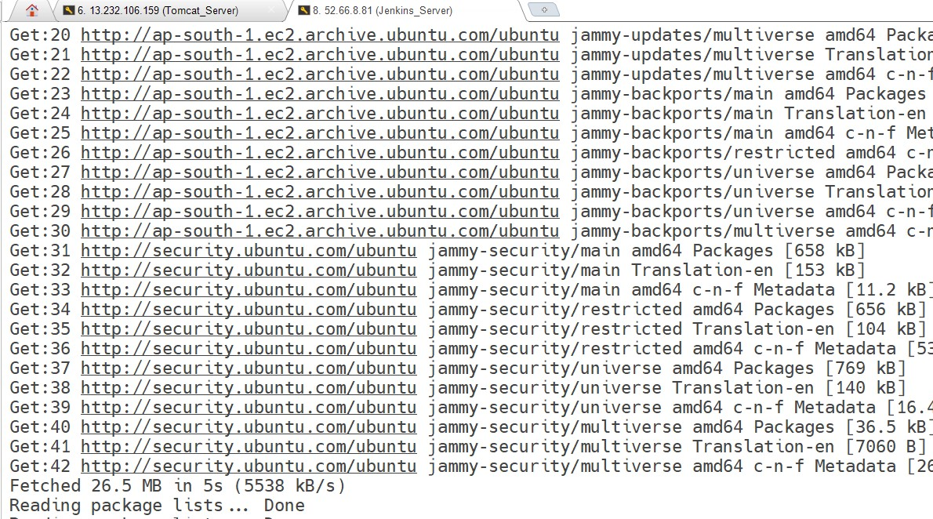

Now, we can proceed further in Jenkins installation, by executing the following commands.

This is the Debian package repository of Jenkins to automate installation and upgrade. To use this repository, first add the key to your system.

**curl -fsSL https://pkg.jenkins.io/debian-stable/jenkins.io-2023.key | sudo tee \**

**/usr/share/keyrings/jenkins-keyring.asc > /dev/null**

Then add a Jenkins apt repository entry, by executing the following command.

**echo deb [signed-by=/usr/share/keyrings/jenkins-keyring.asc] \**

**https://pkg.jenkins.io/debian-stable binary/ | sudo tee \**

**/etc/apt/sources.list.d/jenkins.list > /dev/null**

As we have added Jenkins apt repository, we have to update the apt package list. By executing the following commands.

**sudo apt-get update**

After executing the above commands, the following screen will appear.

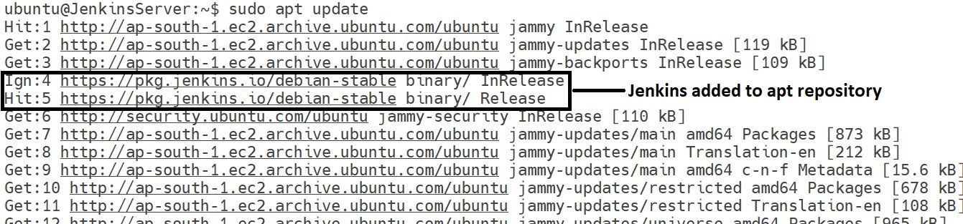

To install Jenkins, prerequisite is JAVA. To install it including supported packages, execute the following command.

**sudo apt-get install fontconfig openjdk-11-jre -y**

After executing the above command, the following screen will be displayed and java will be installed successfully.

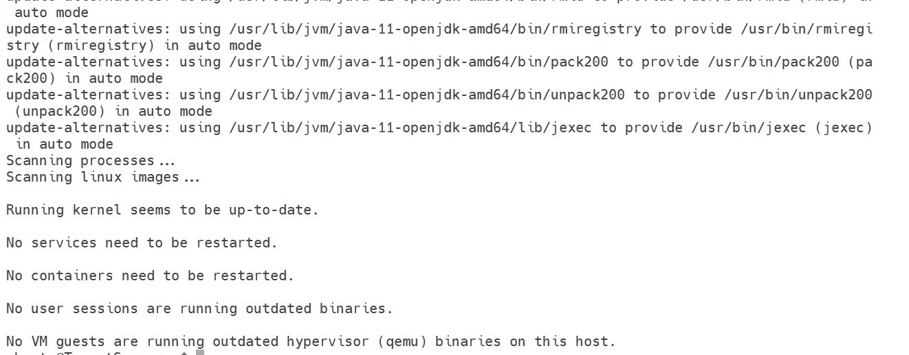

To validate the JAVA installation, execute the following commands in terminal.

**java --version**

After executing that command, the following screen will appear.



Finally, execute the following commands for Jenkins installation.

**sudo apt-get install jenkins -y**

After executing the above commands, jenkins will be installed successfully and to validate its installation and to see its status execute the following commands in terminal.

**sudo systemctl status jenkins**

After executing the above commands, the following screen will appear.

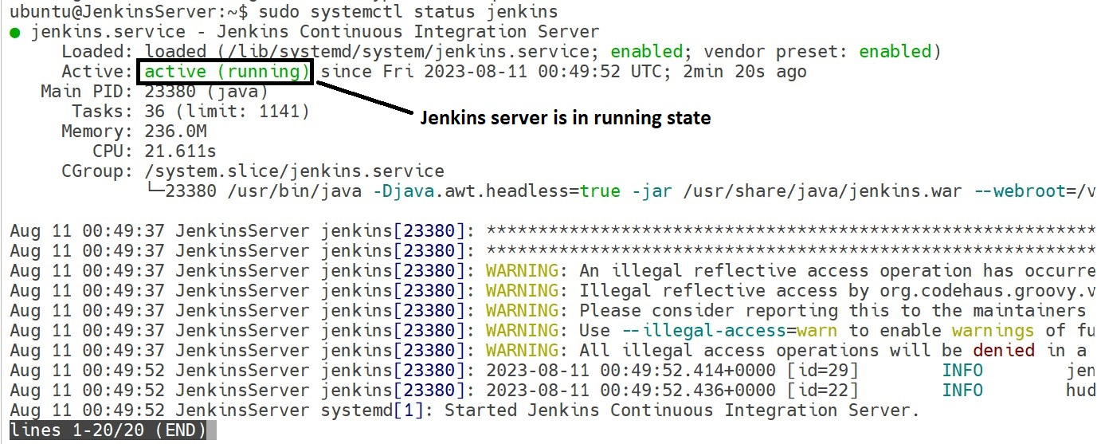

After successful installation of jenkins, go to your browser and enter the following URL for further setup.

**http://YOUR IP :8080 (In AWS security groups, we have to allow 8080 port number)**

After entering the above URL, the following screen will appear.

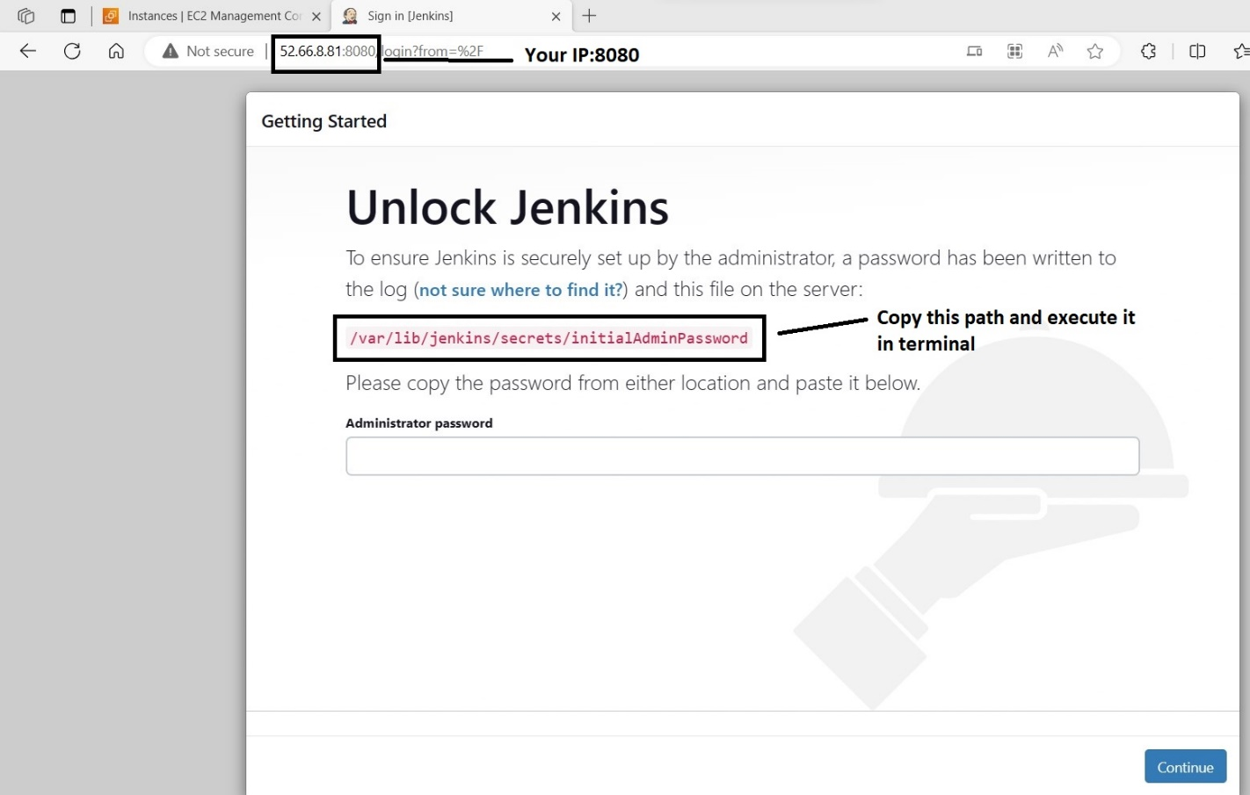

Then you have to copy that given path and execute the following commands in the terminal for initial admin password.

**sudo cat /var/lib/jenkins/secrets/initialAdminPassword**

The following output message will be displayed as shown below.

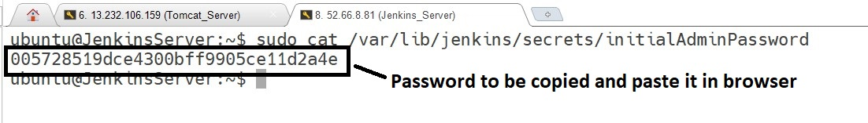

Then you have to copy that password and pasted in browser (administrator password section) and finally click on continue button. As shown in below screenshot.

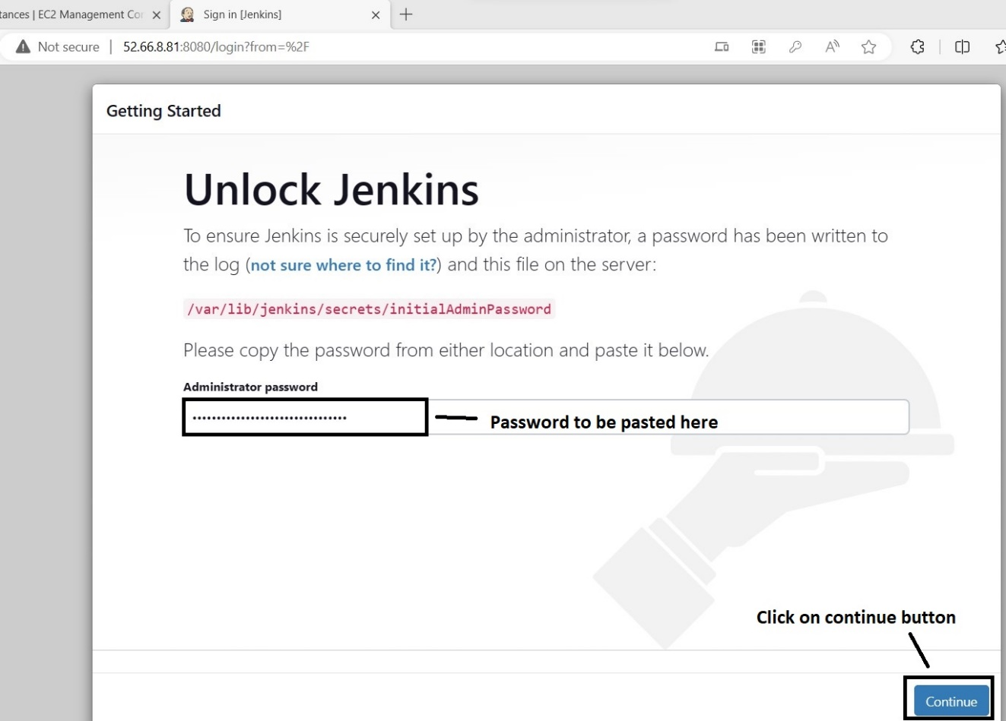

After clicking on continue button, the following page will appear.

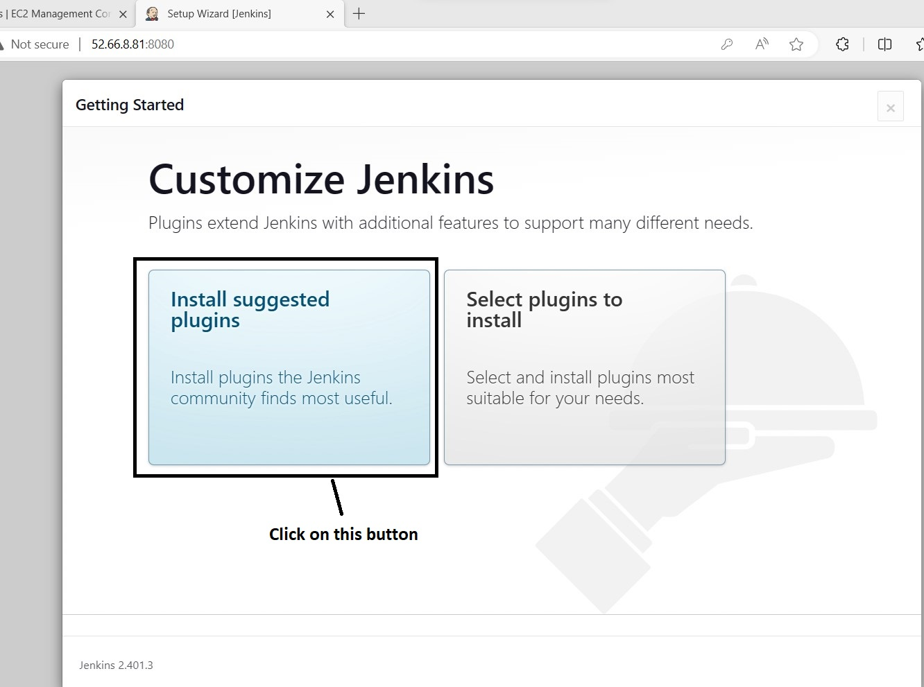

After clicking on ‘Install suggested plugin’ button, the following page will appear.

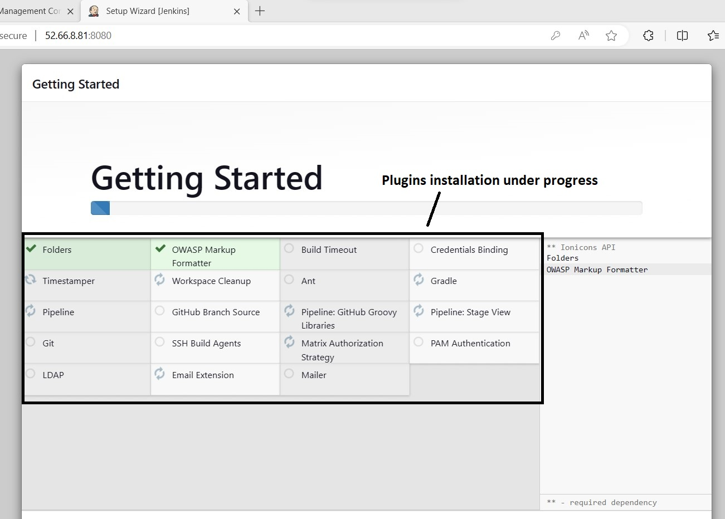

Plugins installation under progress, shown in below screenshot.

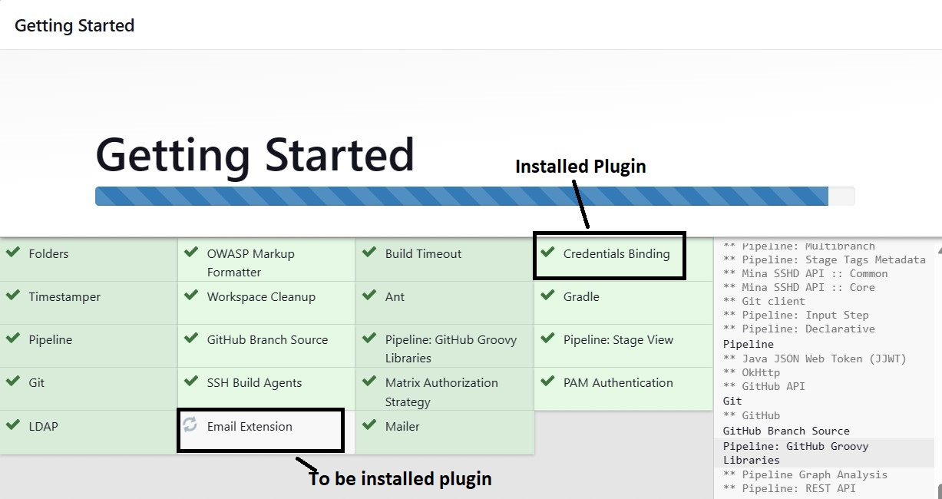

After successful installation of plugins, the following page will appear.

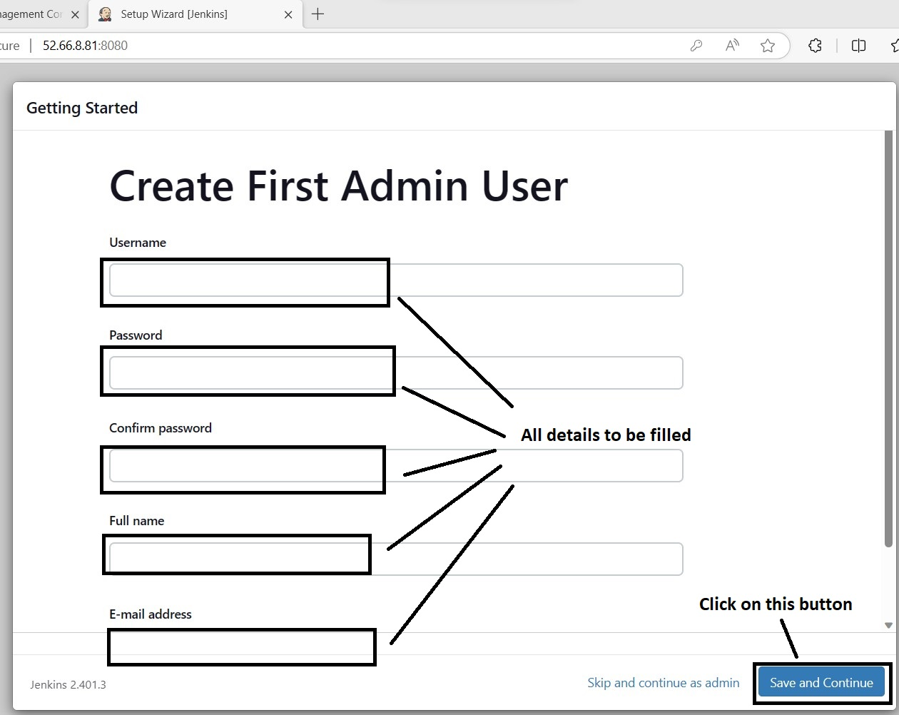

After, clicking on ‘Save and Continue’ button, the following page will appear.

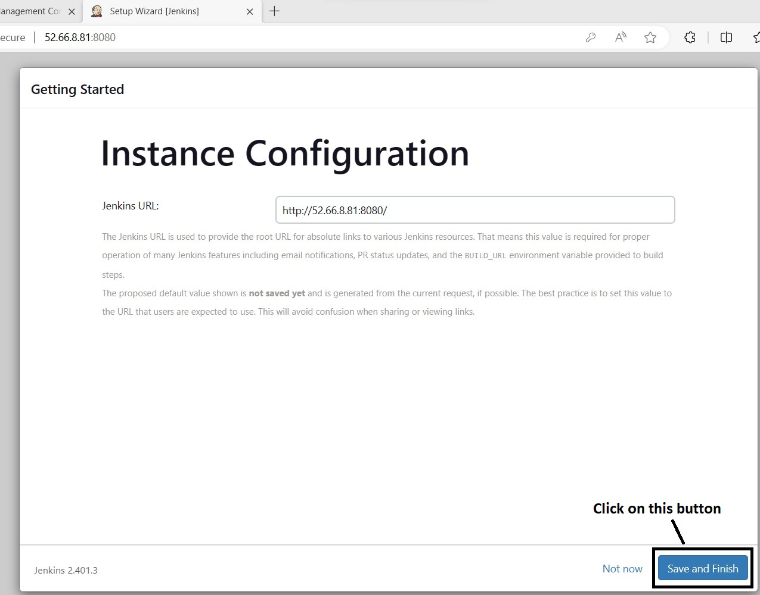

After clicking on ‘Save and Finish’ button, the following page will appear.

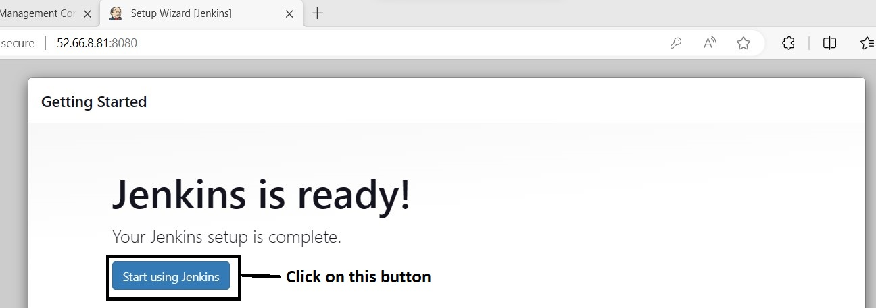

After clicking on ‘Save and Finish’ button the following page will appear.

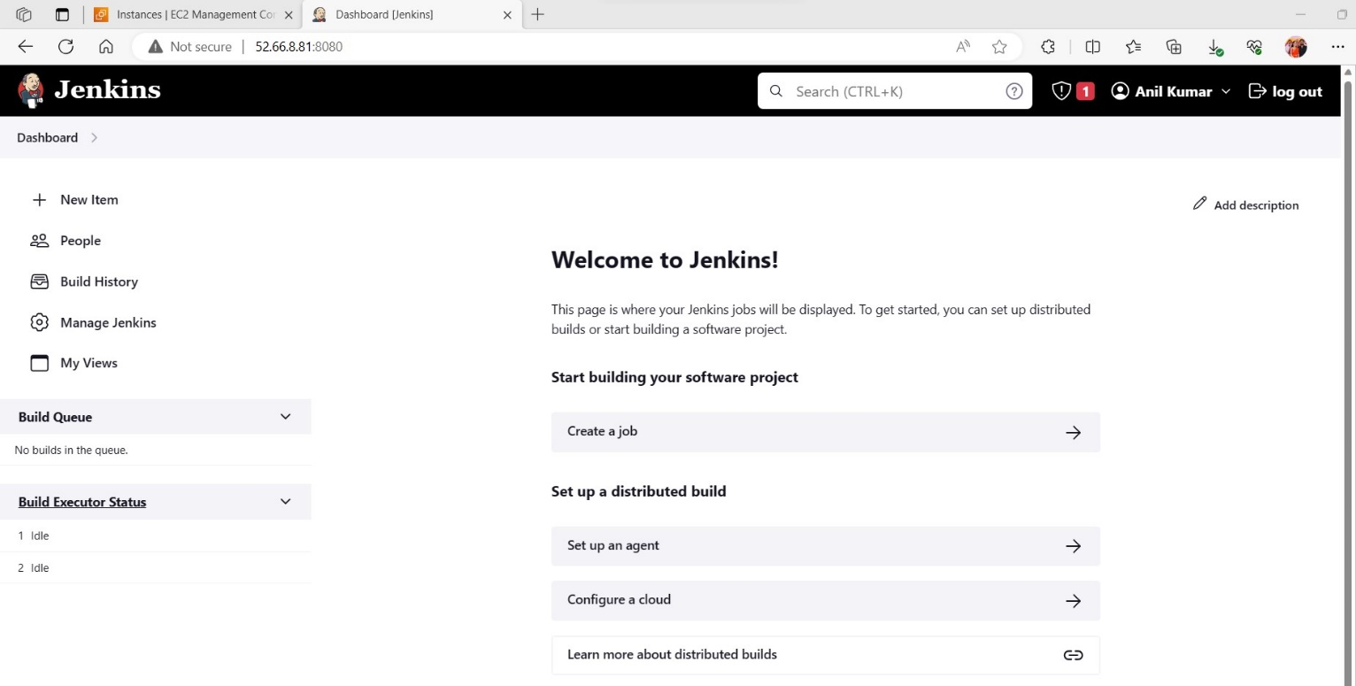

Finally, jenkins setup was completed successfully.

Now, it’s time to setup the **Tomcat server**.

**Step by Step Procedure For Tomcat Server Setup.**

First execute the following command in terminal.

**sudo apt-get update**

After, executing the above command the following page will appear.

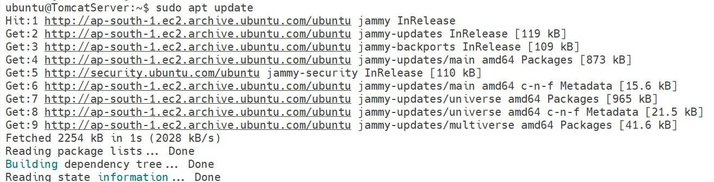

After, updating apt repository execute the following commands to install the Tomcat server.

**sudo apt-get install tomcat9 tomcat9-admin -y**

After, executing the above command tomcat9 will be installed.

To view the tomcat server status, execute the following commands in terminal.

**sudo systemctl status tomcat9**

After executing the above commands, the following screen will appear.

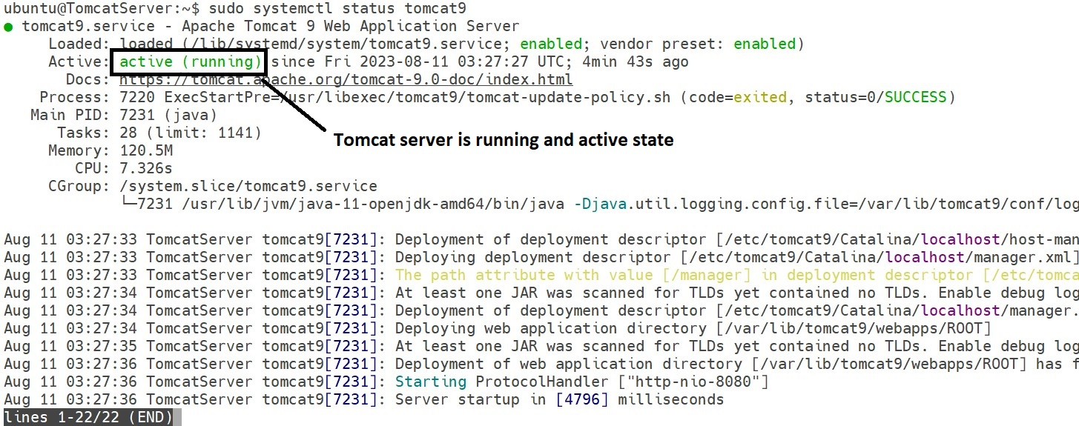

Tomcat server installation completed successfully.

Now, we have to execute the following commands to configure the tomcat users.xml file.

**sudo vi /var/lib/tomcat9/conf/tomcat-users.xml**

After executing the above command, the following screen will appear.

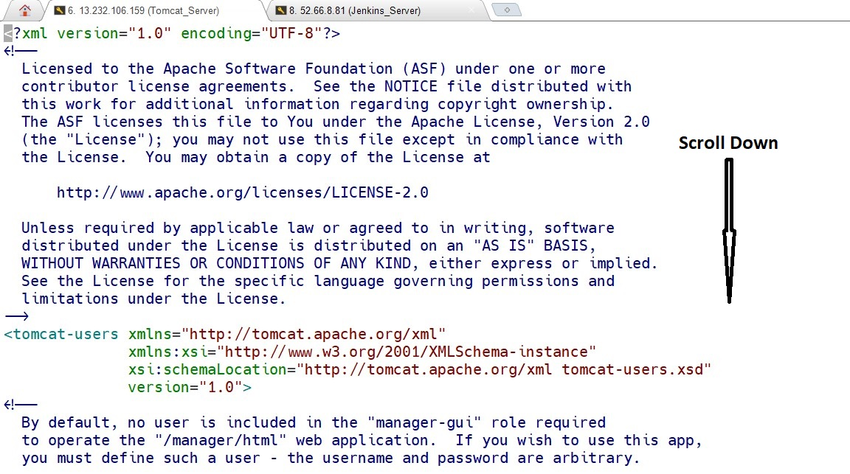

After scrolling down, the following mentioned content will appear.

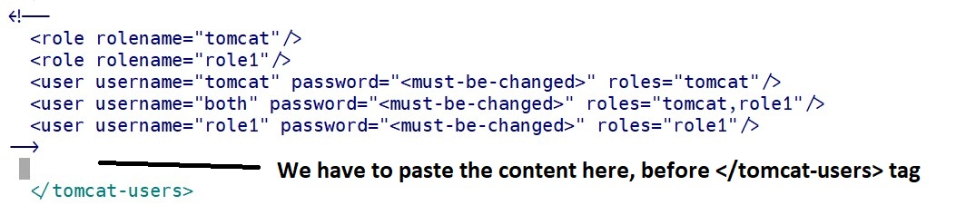

Paste the following content in tomcat-users.xml file, above the </tomcat-users> tag image shown in next page.

**<role rolename="admin-gui"/>**

**<role rolename="admin-script"/>**

**<role rolename="manager-gui"/>**

**<role rolename="manager-script"/>**

**<role rolename="manager-status"/>**

**<user username="tomcat" password="tomcat" roles="manager-script,admin-gui,admin-script,manager-gui,manager-status"/>**

After, pasting the content. Save the file. Based on your editor commands will change.

Ex: For VI it is **:wq** to save the file.

After pasting the content, the page looks like as mentioned below.

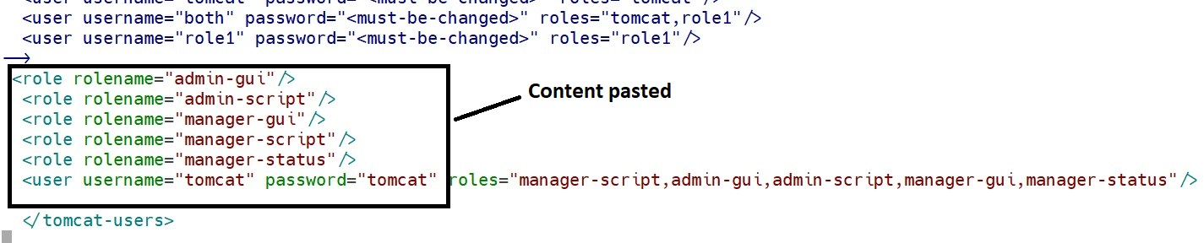

Now, enter the following URL in your browser.

**http://YOUR IP:8080/**

After entering the URL in browser, the following page will appear.

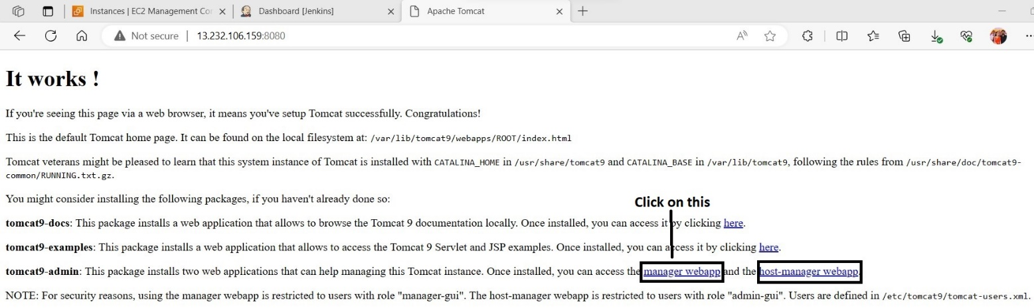

After clicking on ‘manager webapp’ link, the following page will appear.

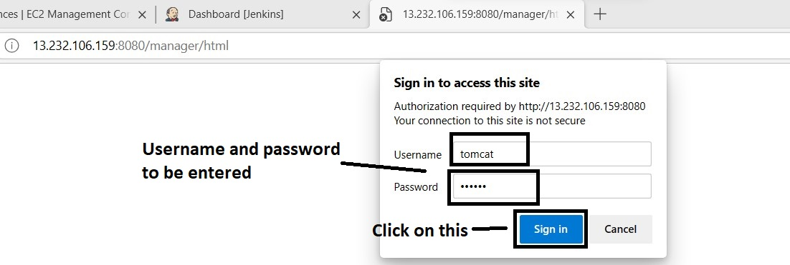

After entering username and password, clicking on ‘**sign in**’ button the following page will appear.

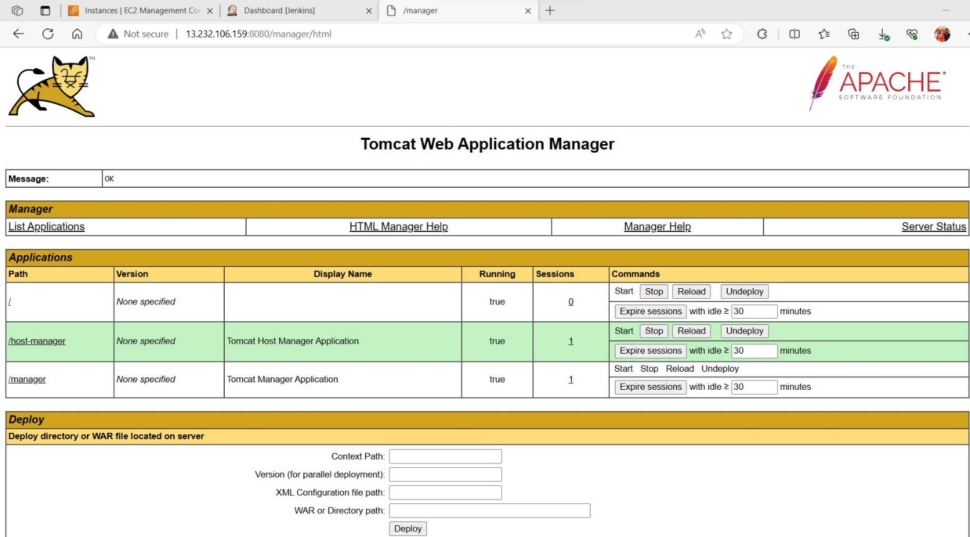

In this page, we can see our deployed applications.

Tomcat is ready to deploy our web applications.

Now, we have to integrate the jenkins and tomcat for deploying our web application. Which is built by maven.

**Step by step process for Integrating jenkins and Tomcat server**

As already we had installed jenkins, open the jenkins dashboard by using following URL

**http://YOUR IP :8080** After entering that URL, the following page appears.

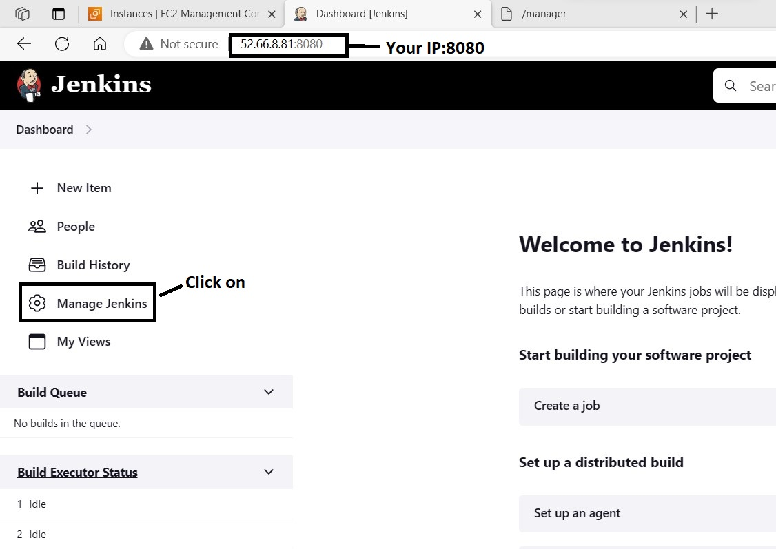

After clicking on ‘**Manage Jenkins’** button, the following page will appear.

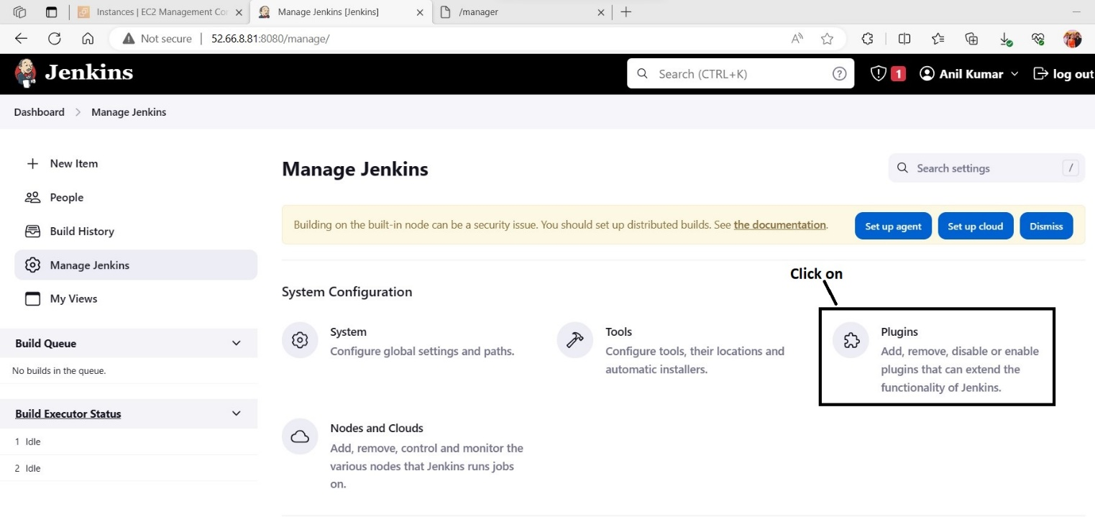

After clicking on ‘**Plugins**’ button, the following page will appear.

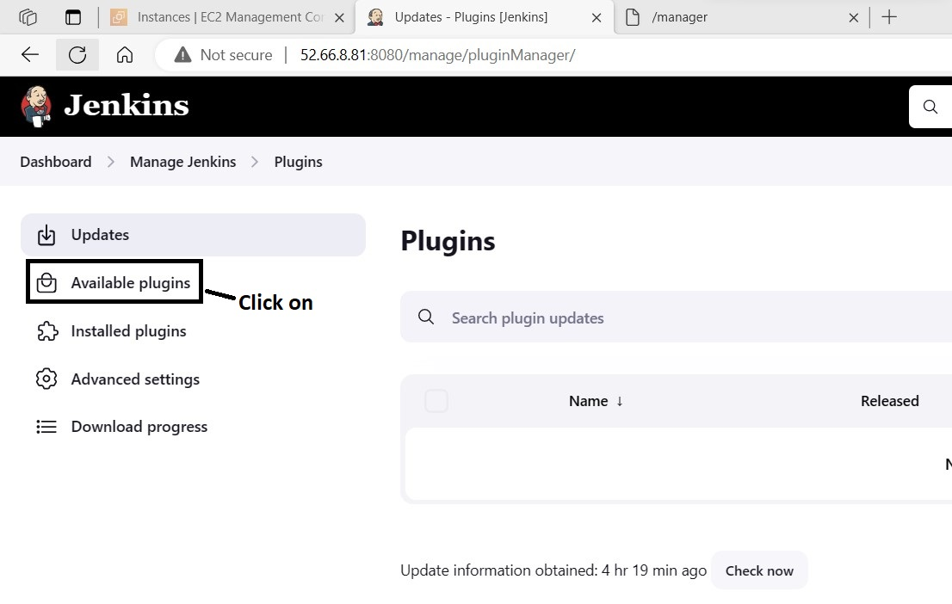

After clicking on ‘**Available Plugins**’ button the following page will appear, then we have to search for deploy to container plugin and it have to be installed.

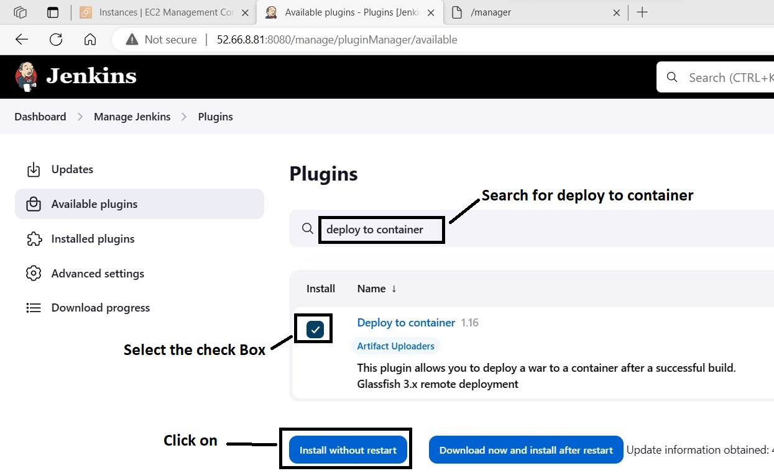

**Note**:- **Deploy to container** plugin is required to integrate jenkins and tomcat.

After clicking on ‘**Install without restart**’ button, the following page will appear.

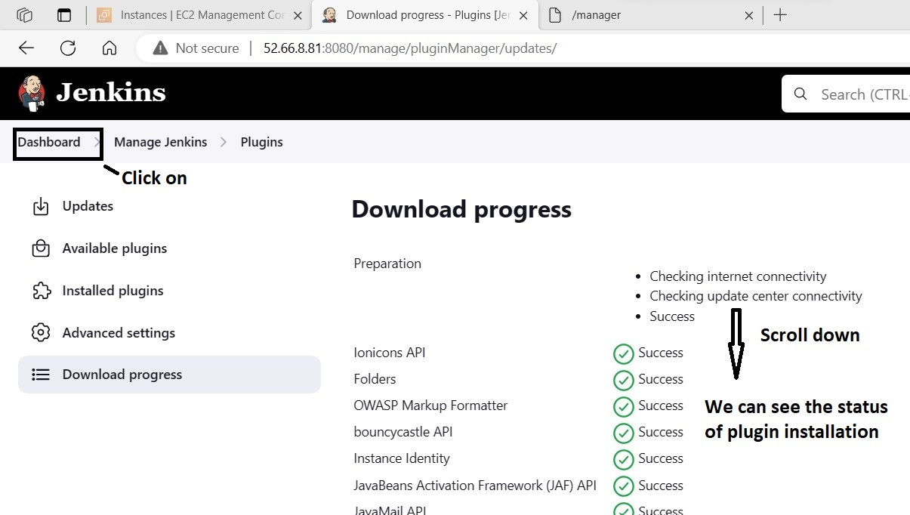

At the bottom, we can see plugin installation status.

After clicking on ‘**Dashboard**’ option, the following page will appear. To build any project initially we require maven tool, to configure it click on ‘**Manage Jenkins**’ button.

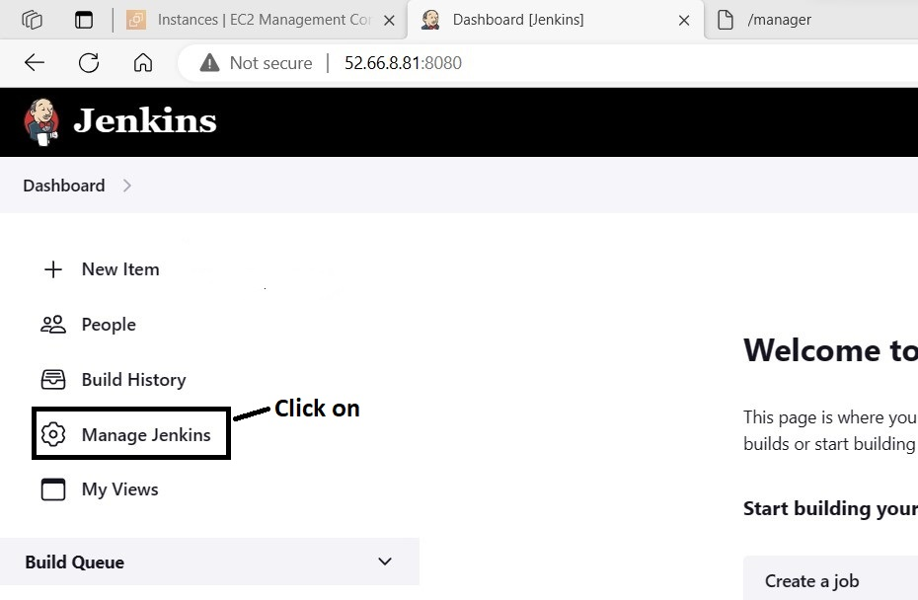

After clicking on ‘**Manage Jenkins**’ button, the following page will appear.

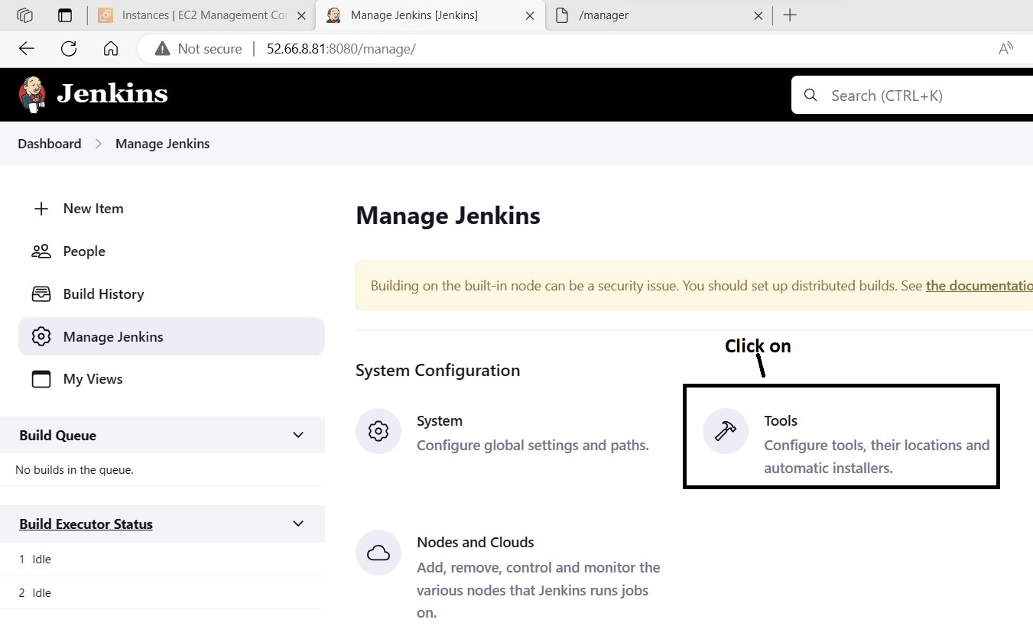

After clicking on ‘**Tools**’ button, the following page will appear.

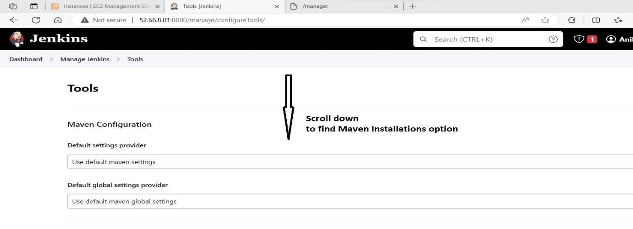

After scrolling down, you can find ‘**Maven Installation**’ option as shown in below screenshot.

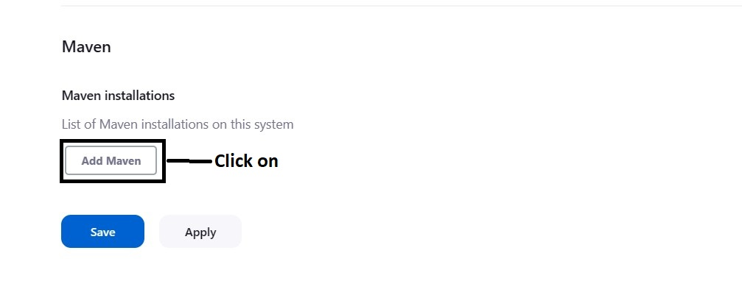

After clicking on ‘**Add Maven**’ button, the following screen will appear.

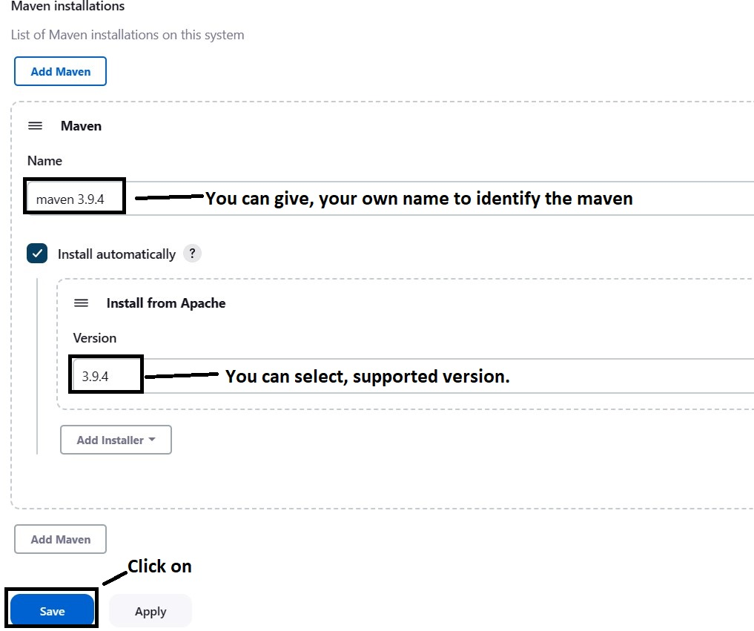

After clicking on ‘**Save**’ button, the following page will appear.

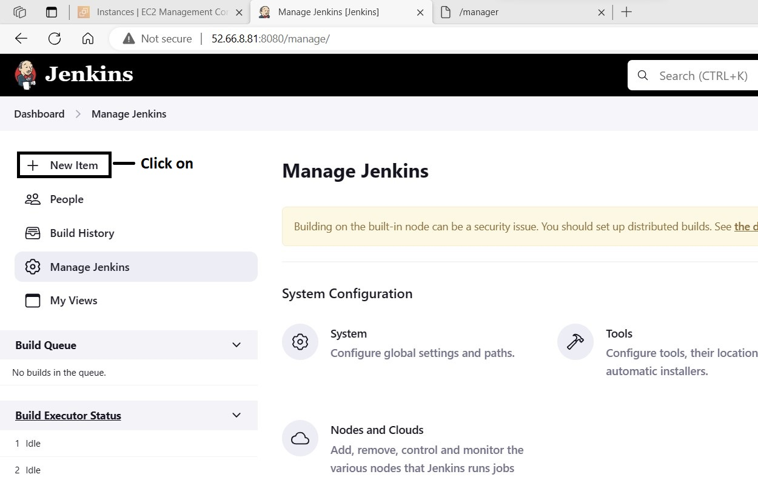

After clicking on ‘**New Item**’ button, the following page will appear.

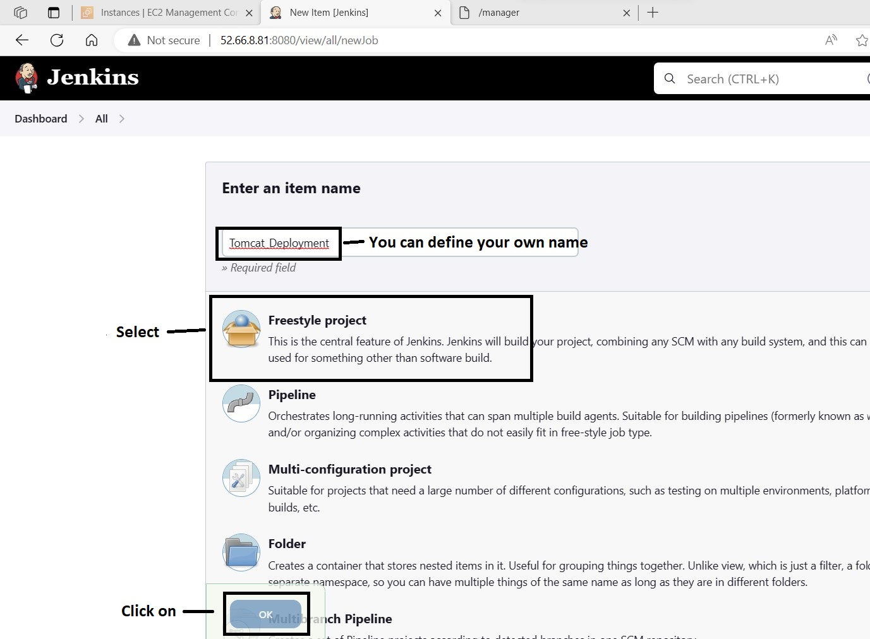

After selecting ‘**freestyle project**’ and clicking on ‘**ok**’, the following page will appear.

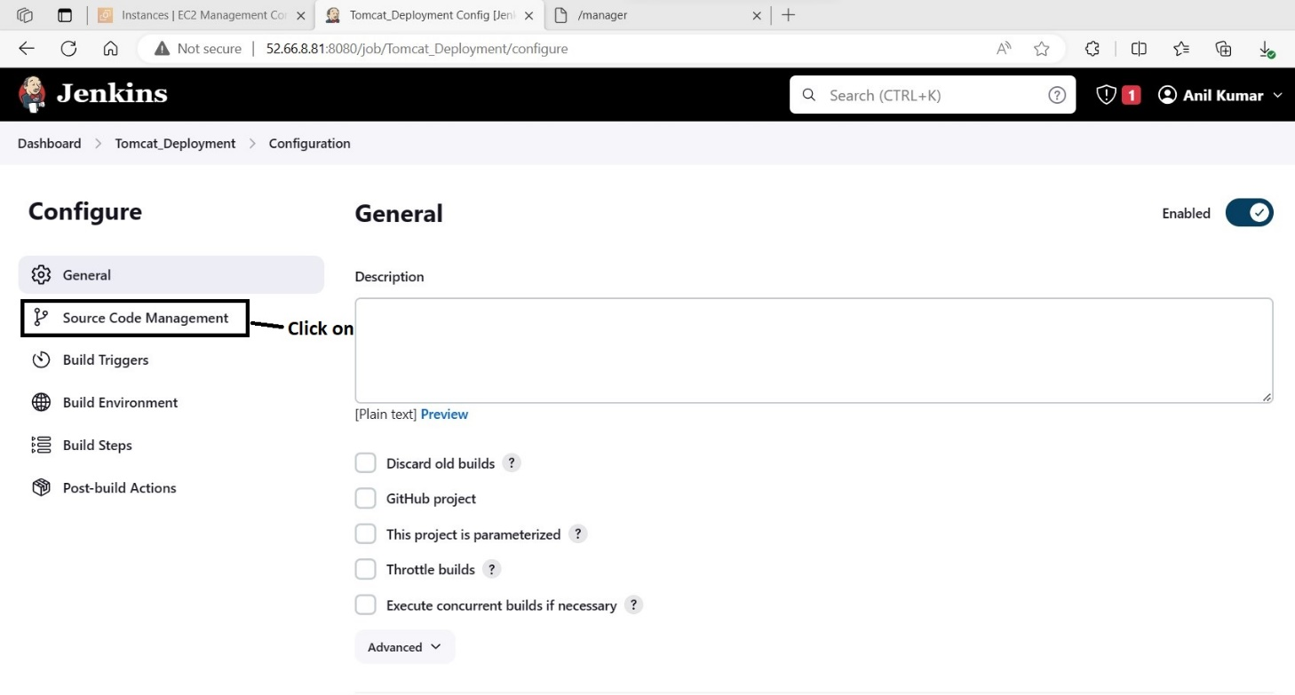

After clicking on ‘**Source code Management**’ button, the following page will appear.

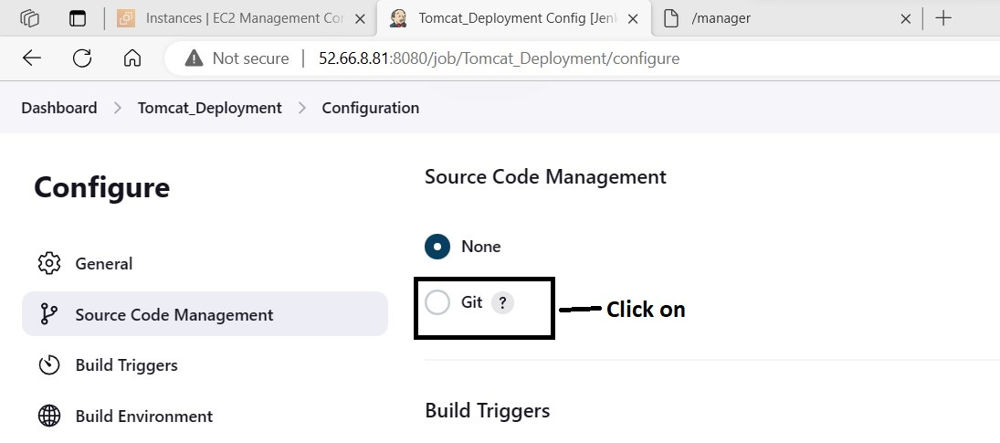

After clicking on ‘**Git**’ button, the following page will appear.

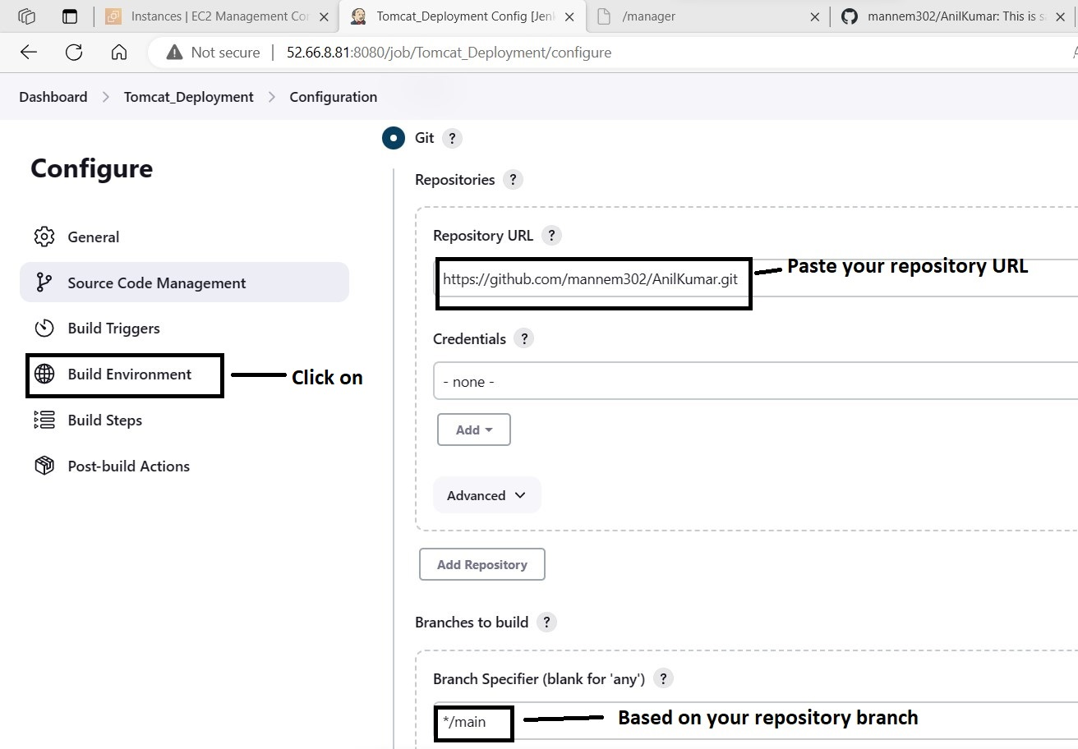

You can see the branch details, in my repository.

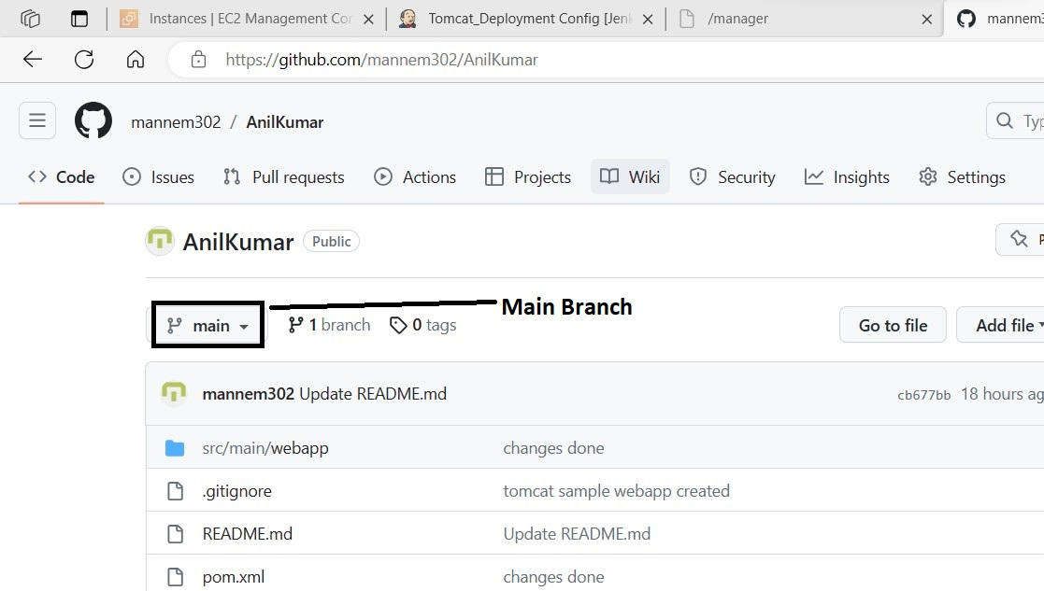

After clicking on ‘**Build Environment**’ option, the following page will appear.

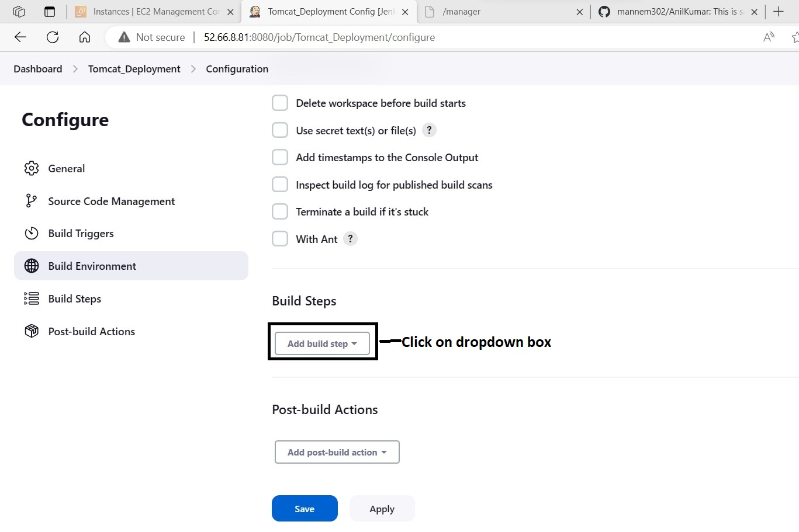

After clicking on ‘**Add build step**’ dropdown box the following page will appear.

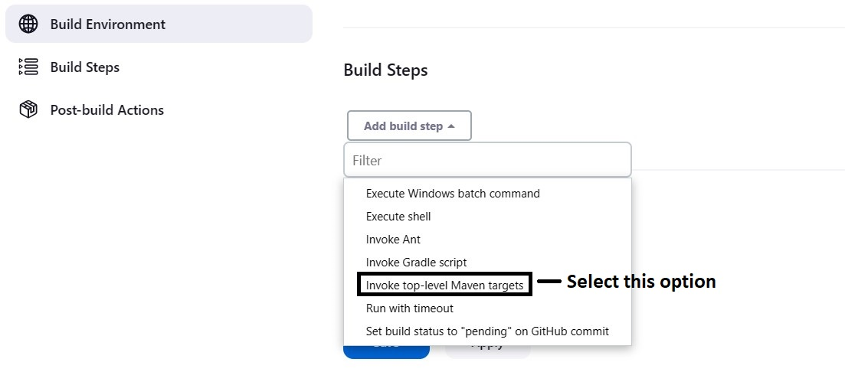

After selecting ‘**Invoke top-level Maven targets**’ options, the following page will appear.

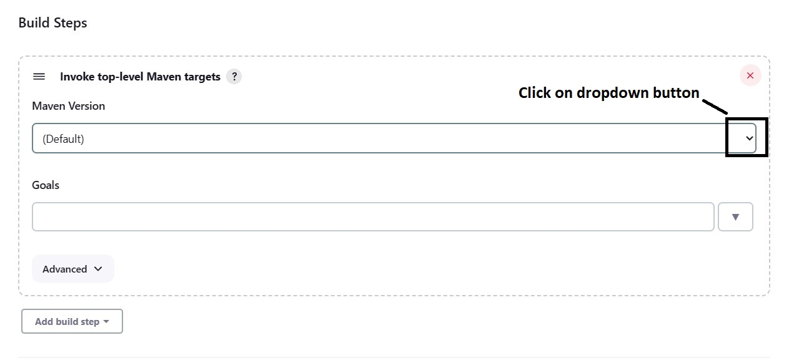

After clicking on dropdown button, the following page will appear.

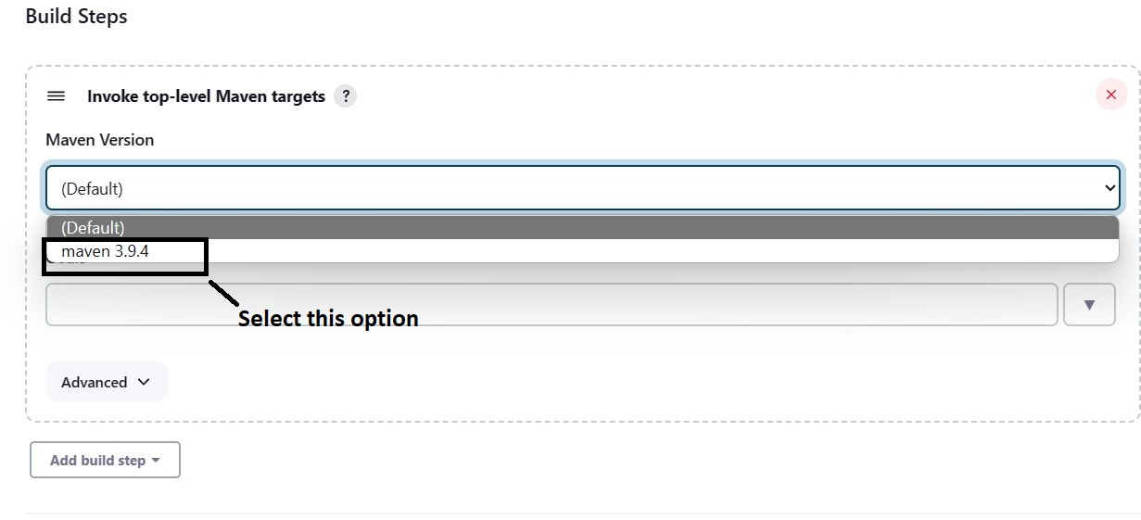

After selecting ‘**maven 3.9.4**’ option, the following page will appear.

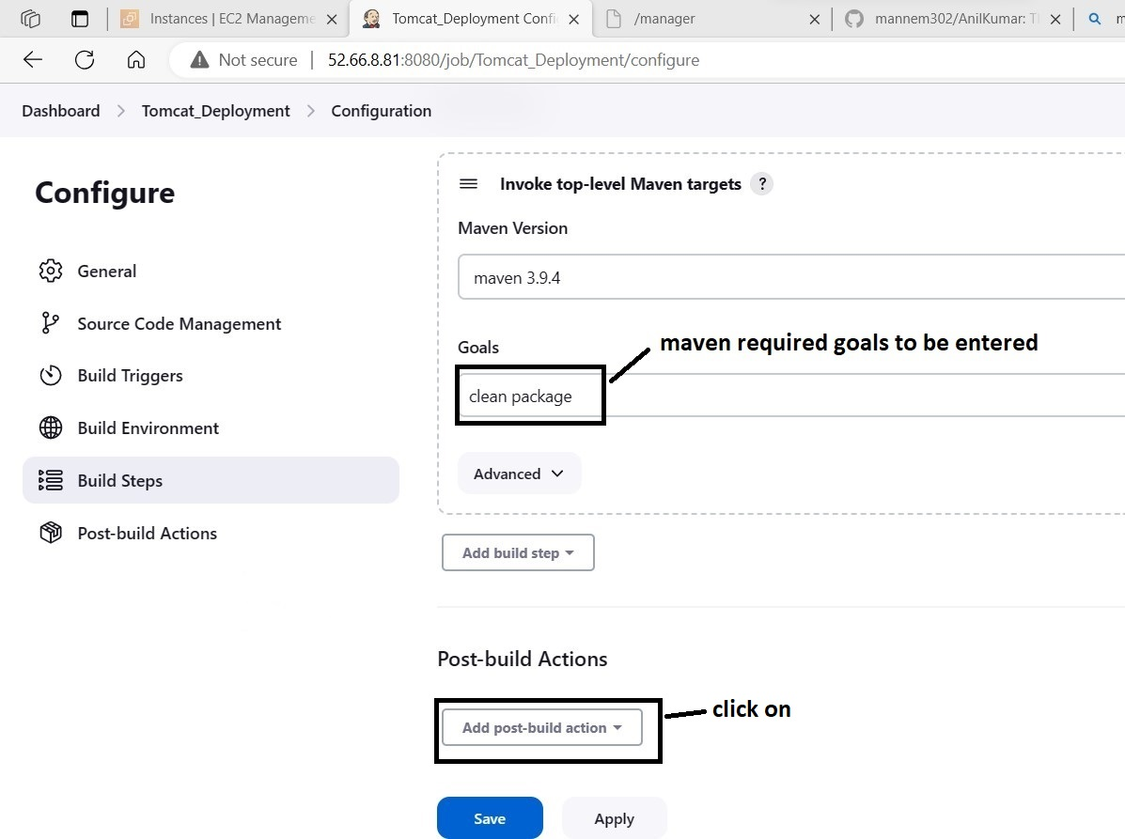

maven goals ‘**clean package**’.

After clicking on ‘**Post-build Actions**’ button, the following page will appear.

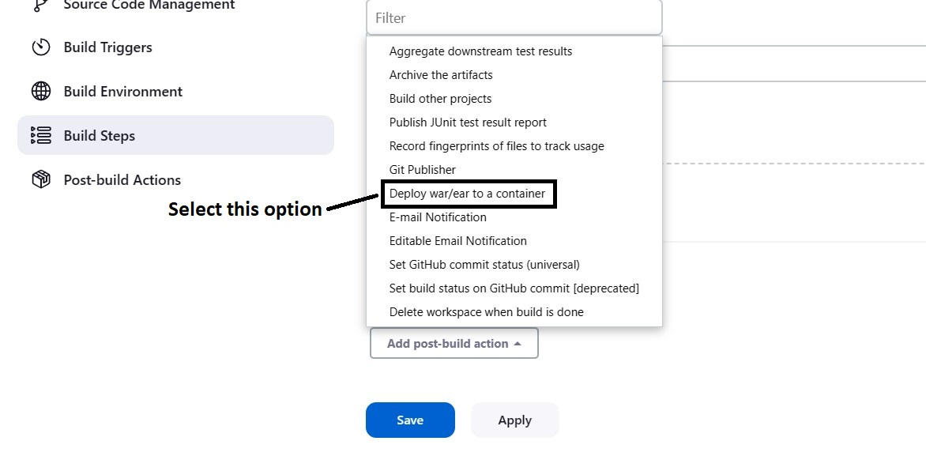

After selecting ‘**Deploy war/ear to a container**’ option, the following page will appear.

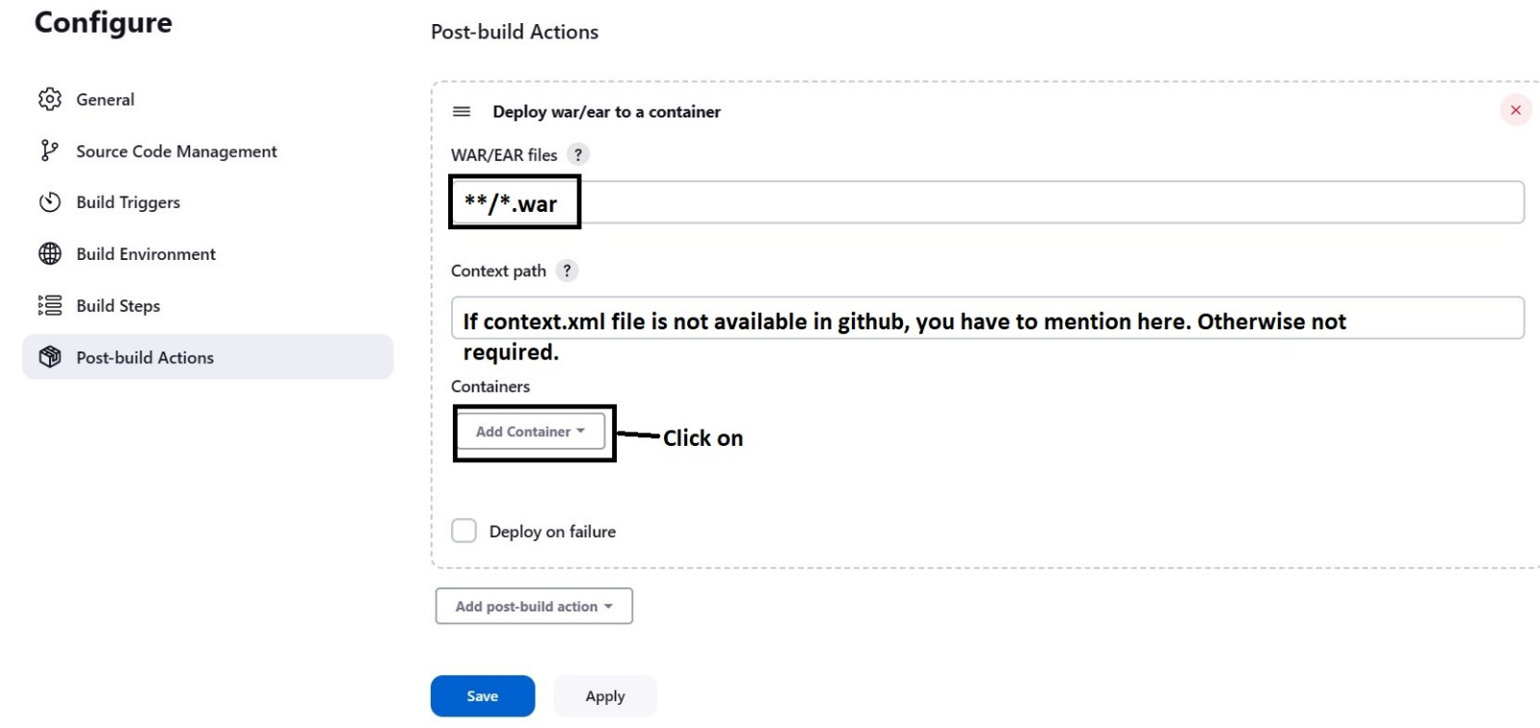

After clicking on ‘**Add Container**’ button, the following page will appear. Based on your tomcat version, you have to select the option.

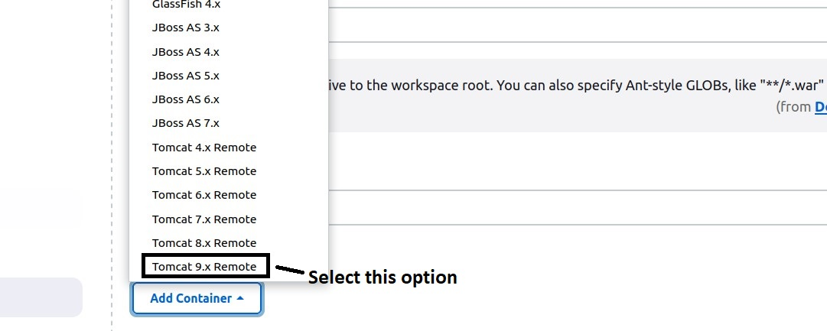

After selecting that ‘**Tomcat 9.x Remote**’ option, the following page will appear.

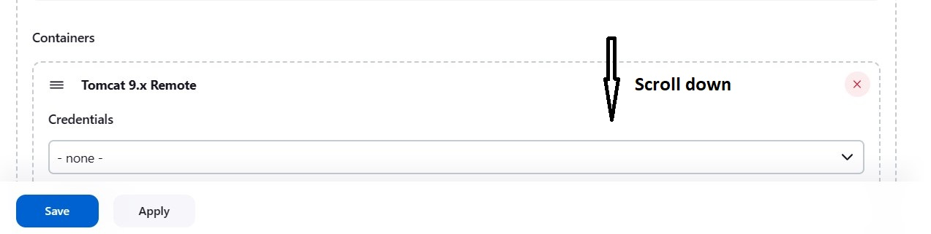

After scrolling down, the following page will appear.

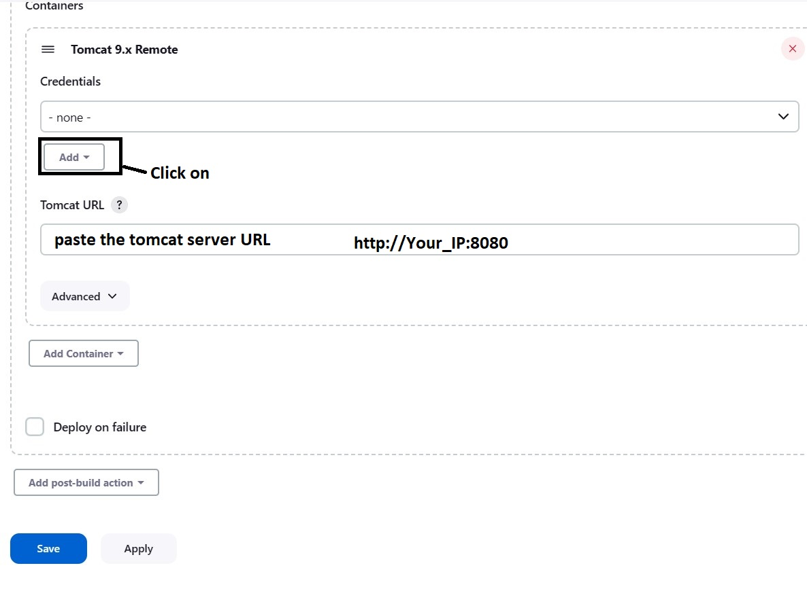

After clicking on ‘**Add**’ dropdown button, the following page will appear.

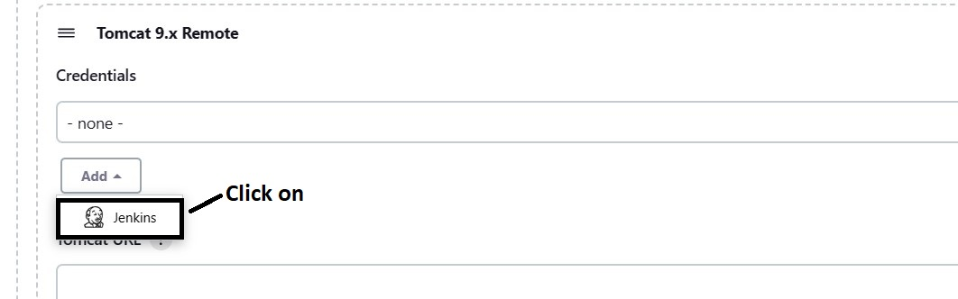

After clicking on ‘**Jenkins**’ option, the following page will appear.

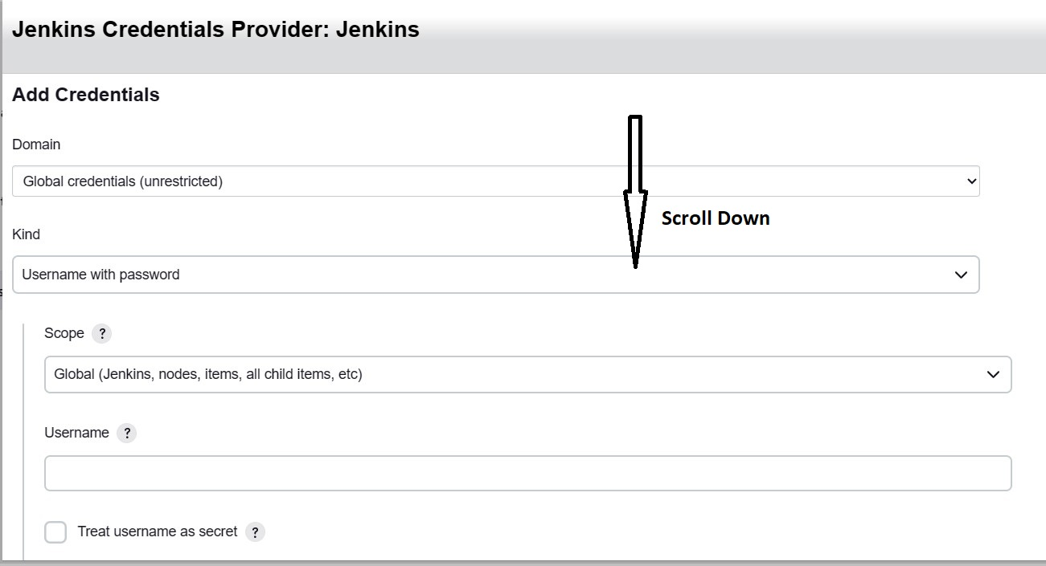

After scrolling down, we can enter ‘username’ and ‘password’ as shown in below screenshot.

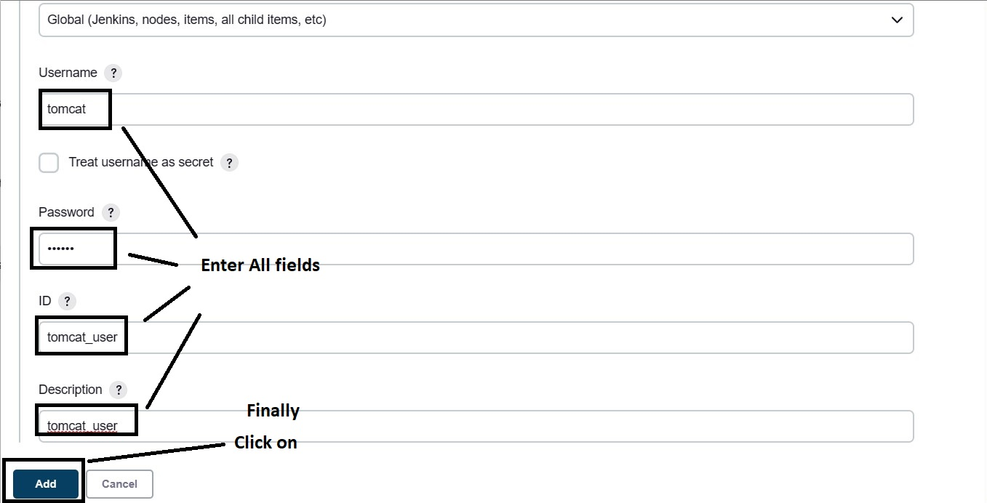

After clicking on ‘**Add**’ button, the following page will appear.

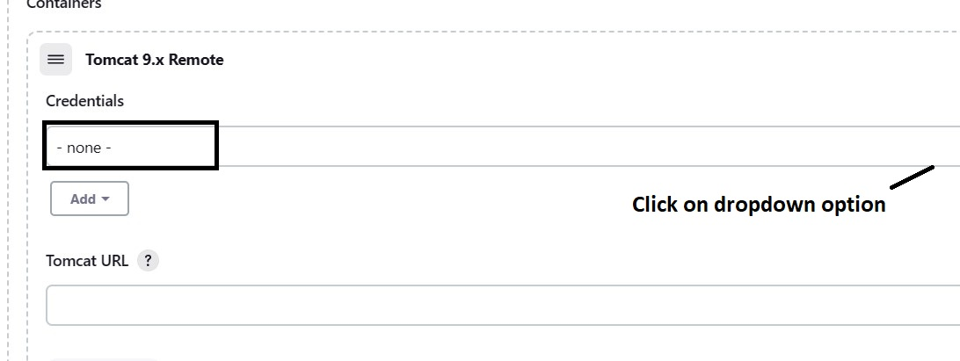

After clicking on dropdown option, the following page will appear.

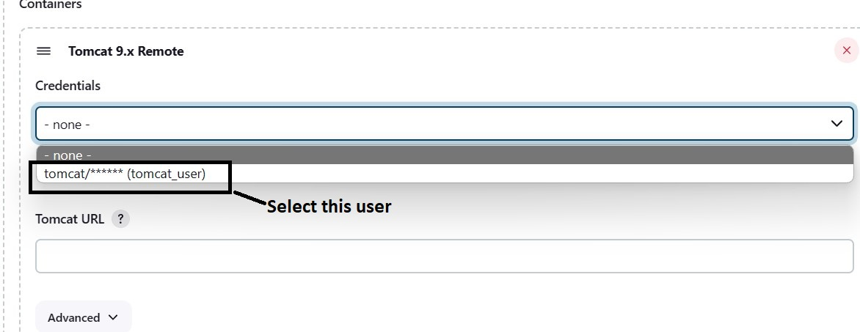

After selecting that user, the following option will appear.

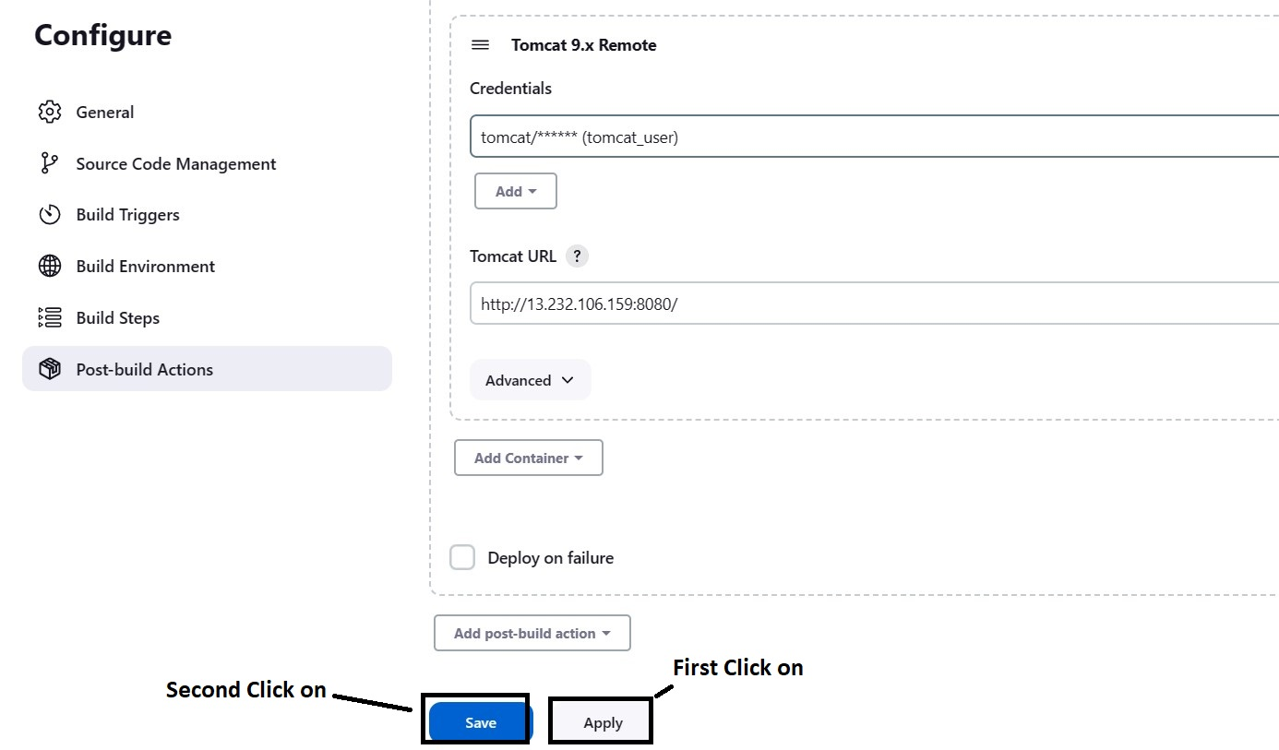

After clicking on ‘**Apply**’ and ‘**Save**’ buttons the following page will appear.

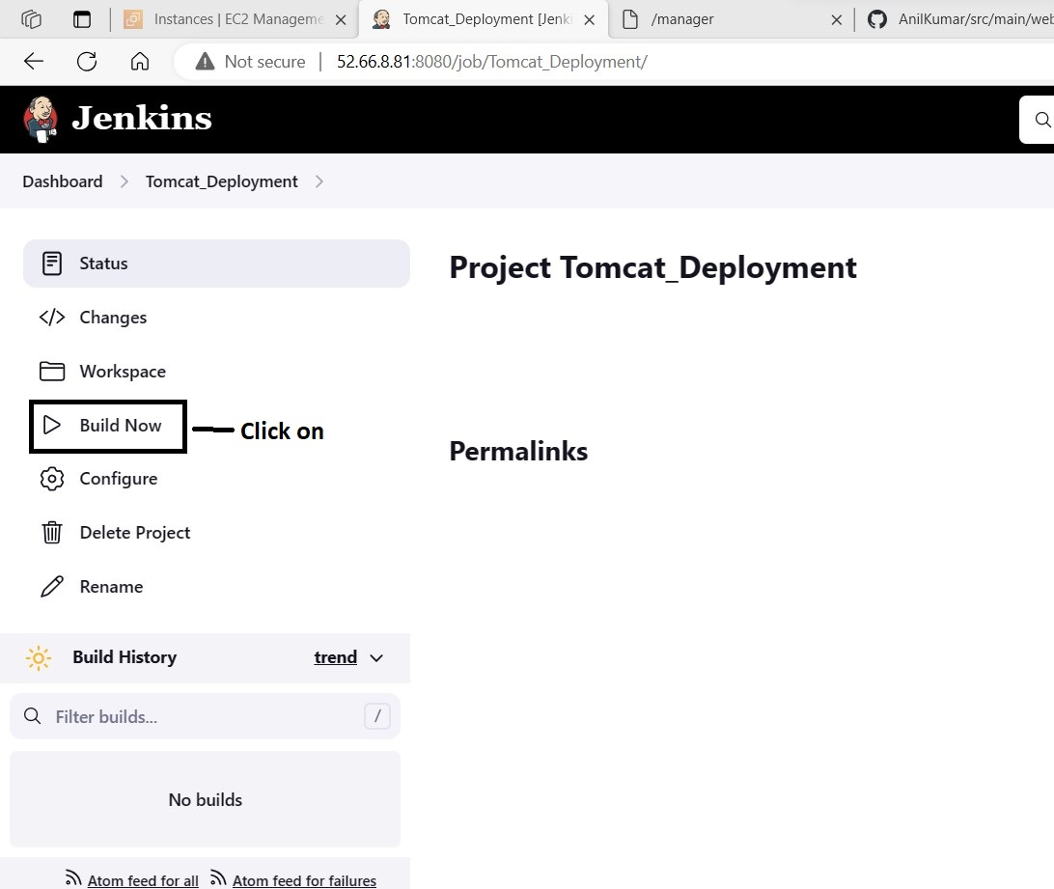

After clicking on ‘**Build Now**’ button, the project deployment process starts as shown in below screenshots.

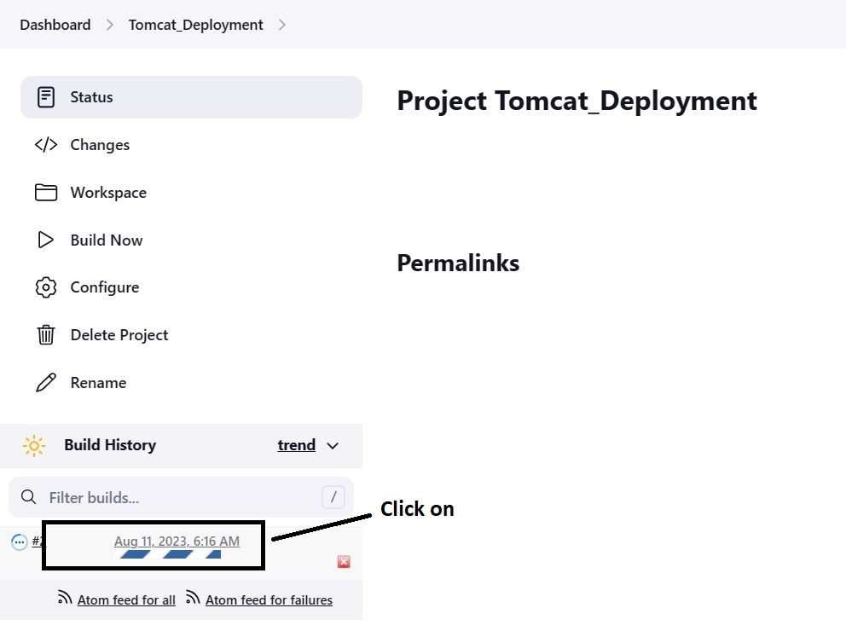

After clicking on that build, the following page will appear.

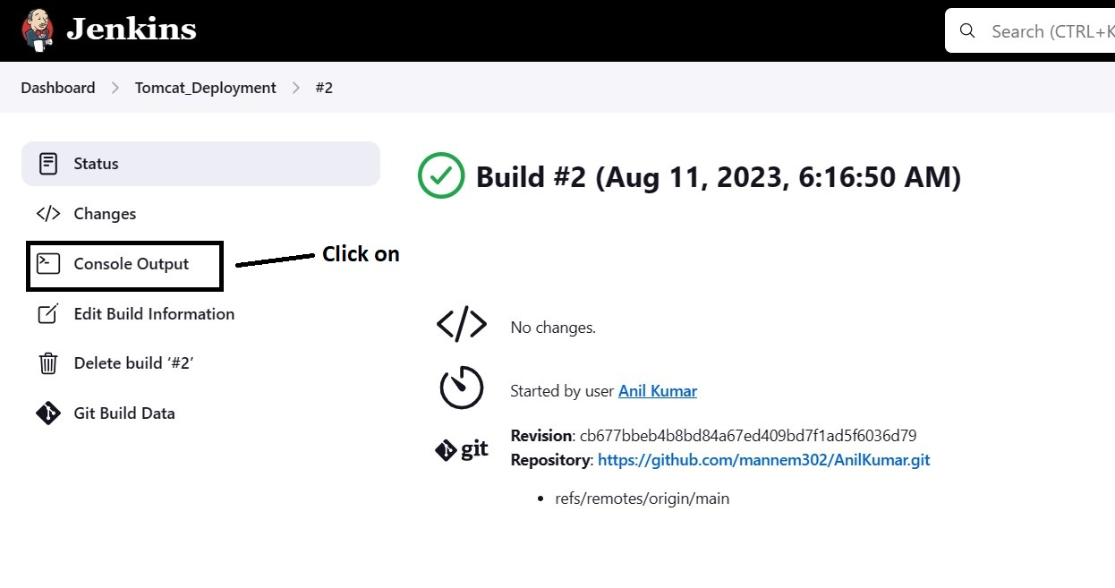

To view the deployment status, click on ‘**Console Output**’ button. After clicking on that button, the following page will appear.

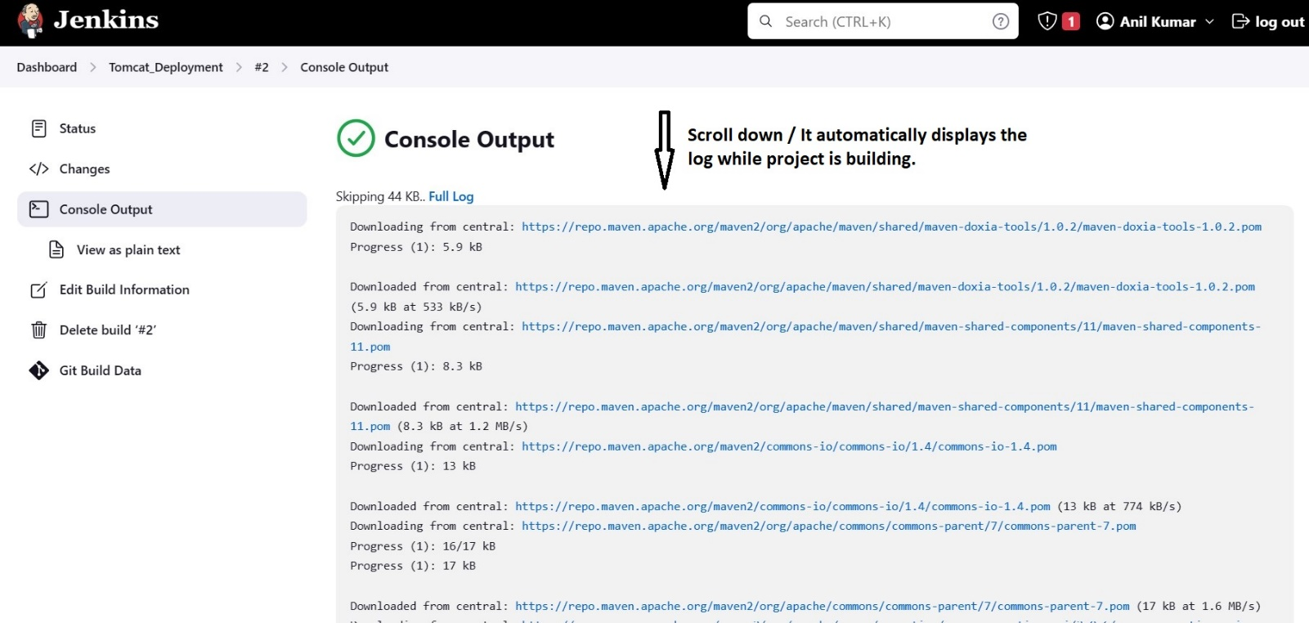

After scrolling down, you can view the project status. As shown in below screenshot.

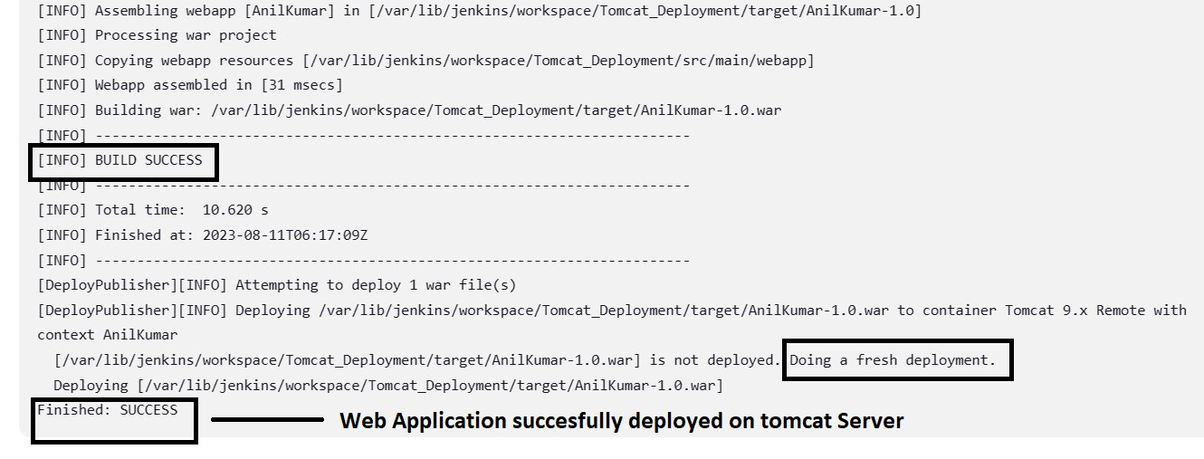

To view the deployed web application, open the tomcat server URL in browser.

**YOUR_IP:8080,** tomcat page opens as shown in following screenshot.

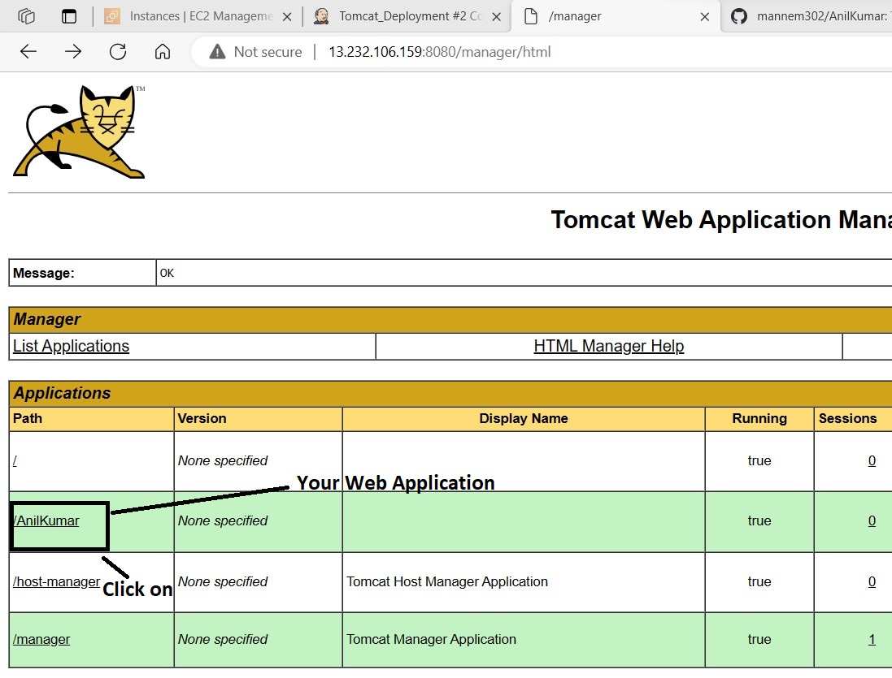

After clicking on that ‘**AnilKumar**’ web application, the following page will appear.

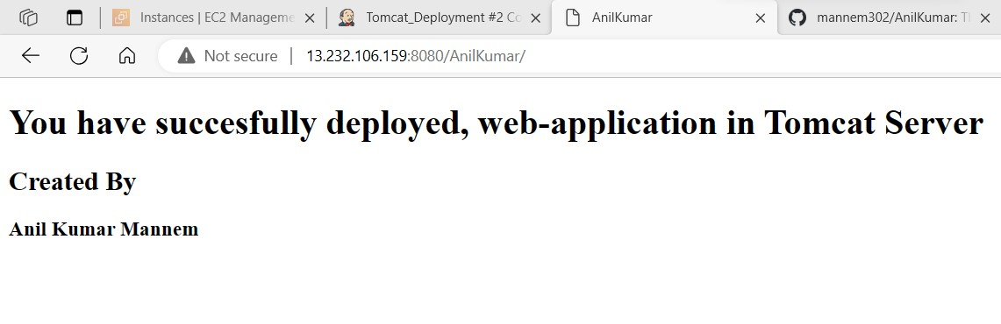

For code quality analysis, initially we require sonarqube server and later we have to integrate it with jenkins.

Follow step by steps for sonarqube installation.

Initially launch a t2.medium instance in AWS and then execute the following commands.

**sudo apt-get update**

After executing the above command, the following screen will appear.

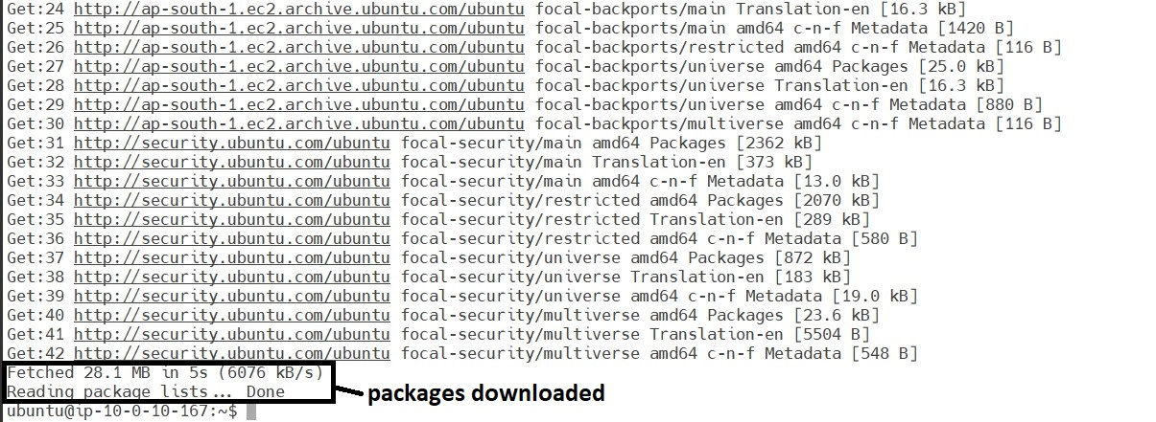

Then, execute the following commands for upgrading the packages.

**sudo apt-get upgrade -y**

After executing the above commands, the following screen will appear.

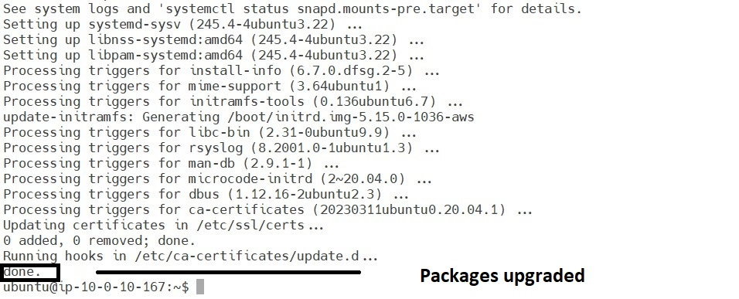

To start the sonarqube server, we require java. To install java execute the following commands.

**sudo apt-get install openjdk-17-jdk -y**

After executing the above command, the following screen will appear.

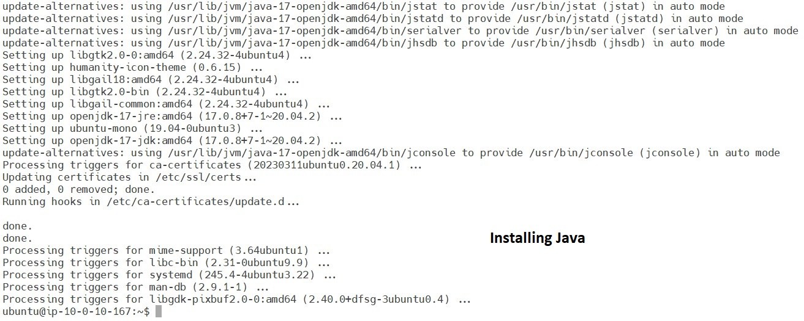

To validate the java installation, execute the following command.

**java --version**

After executing the above command, the following page will appear.

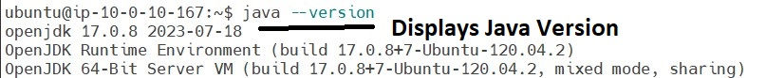

Now execute the following command, to enter into opt directory for downloading sonarqube.

**cd /opt**

After entering into that directory. Execute the below command for downloading.

**sudo wget https://binaries.sonarsource.com/Distribution/sonarqube/sonarqube-9.9.0.65466.zip**

After executing the above command, the following page will appear.

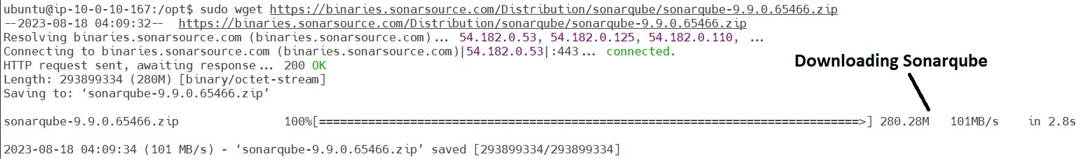

As we have downloaded zip file, to unzip that folder we require unzip software and it shall be installed by executing the following commands.

**sudo unzip sonarqube-9.9.0.65466.zip**

After executing the previous page command, the following page will appear.

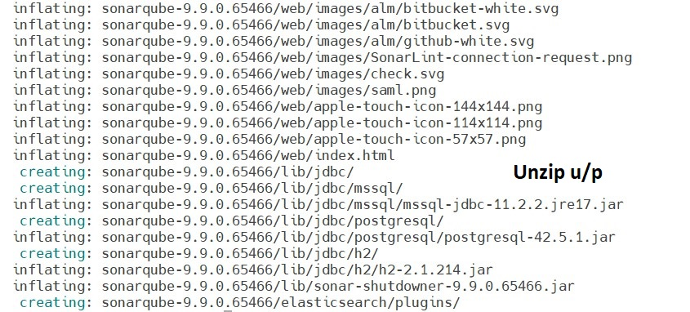

After extracting the zip folder, rename that folder by using the following command.

**sudo mv /opt/sonarqube-9.9.0.65466 /opt/sonarqube**

We can’t run the sonarqube as a root user. So, it’s time to create new group and user to run sonarqube server. Execute the below commands.

**sudo groupadd sonar**

**sudo useradd -c "user to run SonarQube" -d /opt/sonarqube -g sonar sonar**

**sudo chown -R sonar:sonar /opt/sonarqube**

**sudo passwd sonar (set the password)**

Now edit the sonar script file by executing the following commands.

**sudo vi /opt/sonarqube/bin/linux-x86-64/sonar.sh**

After executing the above command, the following page will appear and we have to paste the following content in that file.

**RUN_AS_USER=sonar**

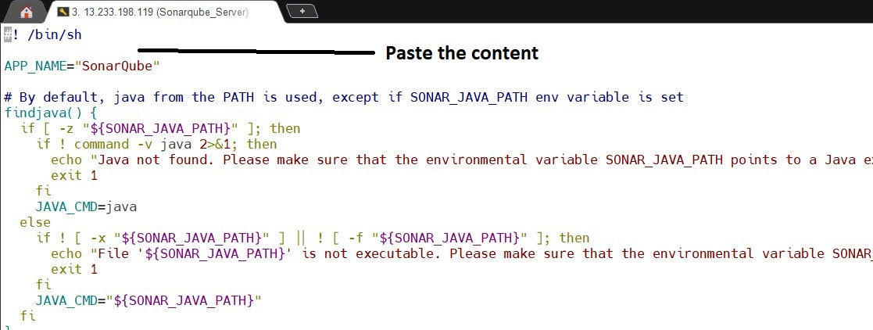

After pasting that content, the page looks like as shown below.

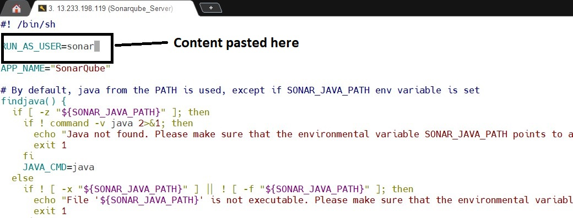

To save the file **:wq**

Now, give the sudo access to the sonar user, by executing the following command.

**sudo visudo**

After executing the above command, the following page will appear and the following content to be pasted.

**sonar ALL=(ALL:ALL) ALL**

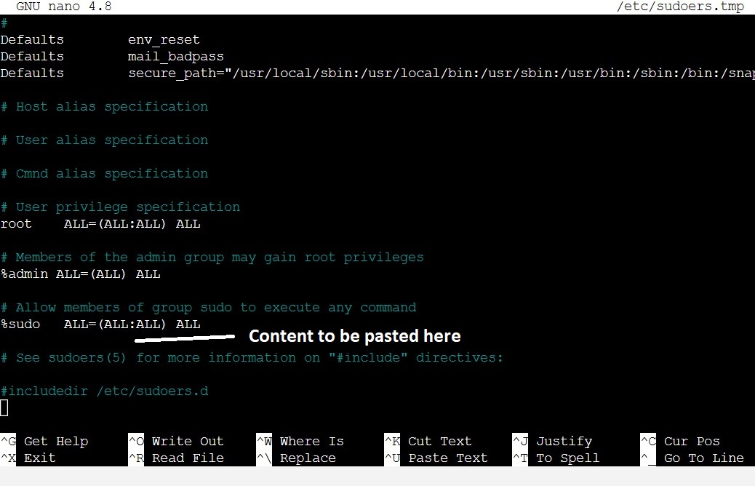

After pasting the content, the page looks like as shown below.

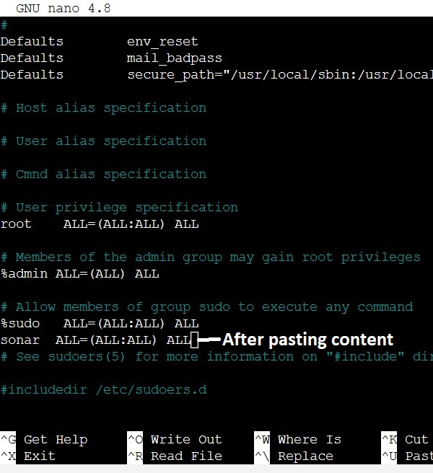

press ctrl+x to save the file.

Now, view the default shell used for sonar user, by executing the following command.

**sudo vi /etc/passwd**

After executing the above command, the following page will appear.

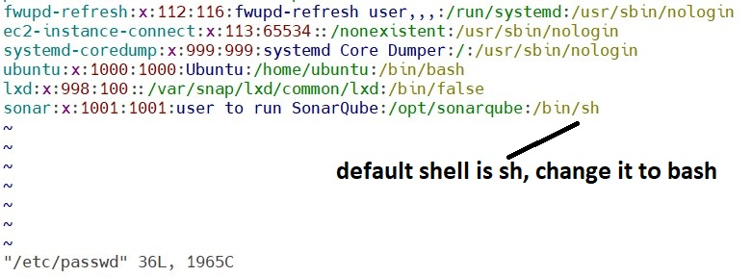

After changing sh to bash, the page looks like as shown below.

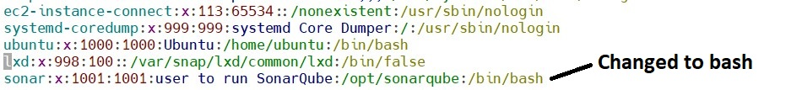

press esc and :wq to save the file.

Now, before starting sonarqube service. Switch to sonar user by executing following command.

**sudo su sonar**

After executing the above command, the following page will appear.

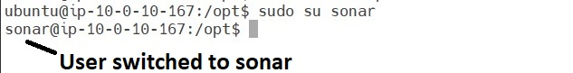

Then execute the following command, for entering into sonarqube directory and start the service.

**cd /opt/sonarqube/bin/linux-x86-64/**

**./sonar.sh start**

After executing the above command, the following page will appear.

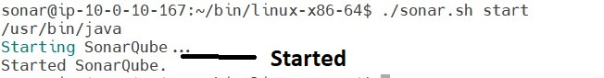

Now, execute the following command to check the sonarqube status

**./sonar.sh status**

After executing the above command, the following page will appear.



After executing the above commands, check the sonarqube logs, by using following commands.

**tail /opt/sonarqube/logs/sonar.log**

After executing the previous page command, the following page will appear.

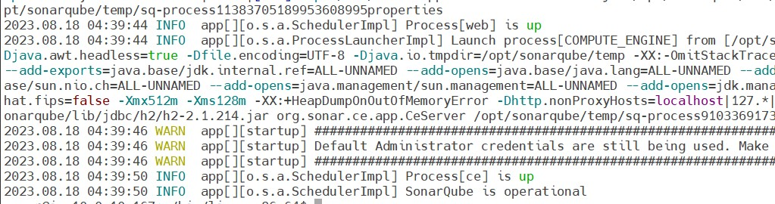

Now, stop the service and add the system service, by executing the following command.

**./sonar.sh stop**

After executing the above command, the following page will appear.

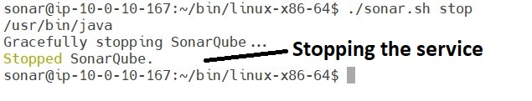

After stopping the service, execute the following command. To create systemd service.

**sudo vi /etc/systemd/system/sonar.service**

After executing the above command, the following page will appear.

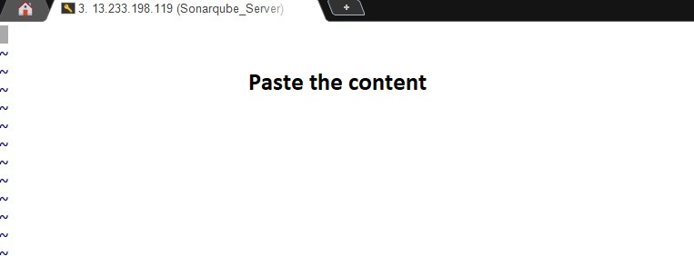

Content mentioned in the next page shall be pasted in above screen.

**[Unit]**

**Description=SonarQube service**

**After=syslog.target network.target**

**[Service]**

**Type=forking**

**ExecStart=/opt/sonarqube/bin/linux-x86-64/sonar.sh start**

**ExecStop=/opt/sonarqube/bin/linux-x86-64/sonar.sh stop**

**User=sonar**

**Group=sonar**

**Restart=always**

**LimitNOFILE=65536**

**LimitNPROC=4096**

**[Install]**

**WantedBy=multi-user.target**

After pasting the content, execute the following command to start the sonarqube service.

**sudo systemctl start sonar**

After starting the service, check the status by executing the following commands.

**sudo systemctl status sonar**

After executing the above command, the following page will appear.

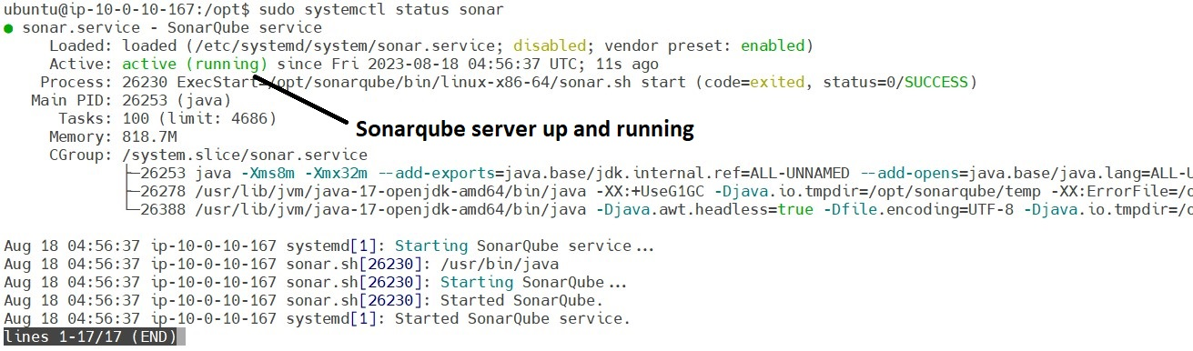

We can enable the sonarqube service at system startup by using the following command.

**sudo systemctl enable sonar**

After executing the above command, the following page will appear.

